

**Activate SharePoint Online Migration**

**Scenario Guide 2.2**

Use Power BI Desktop to Analyze SMAT data



**Conditions and Terms of Use**

**Microsoft Confidential**

This training package is proprietary and confidential, and is intended only for uses described in the training materials. Content and software is provided to you under a Non-Disclosure Agreement and cannot be distributed. Copying or disclosing all or any portion of the content and/or software included in such packages is strictly prohibited.

The contents of this package are for informational and training purposes only and are provided "as is" without warranty of any kind, whether express or implied, including but not limited to the implied warranties of merchantability, fitness for a particular purpose, and non-infringement.

Training package content, including URLs and other Internet Web site references, is subject to change without notice. Because Microsoft must respond to changing market conditions, the content should not be interpreted to be a commitment on the part of Microsoft, and Microsoft cannot guarantee the accuracy of any information presented after the date of publication. Unless otherwise noted, the companies, organizations, products, domain names, e-mail addresses, logos, people, places, and events depicted herein are fictitious, and no association with any real company, organization, product, domain name, e-mail address, logo, person, place, or event is intended or should be inferred.

**Copyright and Trademarks**

© 2021 Microsoft Corporation. All rights reserved.

Microsoft may have patents, patent applications, trademarks, copyrights, or other intellectual property rights covering subject matter in this document. Except as expressly provided in written license agreement from Microsoft, the furnishing of this document does not give you any license to these patents, trademarks, copyrights, or other intellectual property.

Complying with all applicable copyright laws is the responsibility of the user. Without limiting the rights under copyright, no part of this document may be reproduced, stored in or introduced into a retrieval system, or transmitted in any form or by any means (electronic, mechanical, photocopying, recording, or otherwise), or for any purpose, without the express written permission of Microsoft Corporation.

For more information, see Use of Microsoft Copyrighted Content at

<http://www.microsoft.com/en-us/legal/intellectualproperty/Permissions/default.aspx>

DirectX, Hyper-V, Internet Explorer, Microsoft, Outlook, OneDrive, SQL Server, Windows, Microsoft Azure, Windows PowerShell, Windows Server, Windows Vista, and Zune are either registered trademarks or trademarks of Microsoft Corporation in the United States and/or other countries. Other Microsoft products mentioned herein may be either registered trademarks or trademarks of Microsoft Corporation in the United States and/or other countries. All other trademarks are property of their respective owners.

Contents

2.2 Preparing the Power BI Desktop SMAT Analysis Package 6

**Objective** 6

**Scenario** 6

**Getting started** 6

Prerequisites 6

Start scenario 6

2.2.1 Download & Extract the Power BI SMAT Analysis Package 6

2.2.2 Copy SMAT Output to the Power BI location 7

2.2.3 Update the Report Folder Path parameter in the Power BI settings 7

2.3 Optional – Run Data Collection Scripts 8

**2.3.1** SCRIPT: **ReportLastModifiedDateAllListsInFarm.ps1** 9

2.3.2 SCRIPT: **ReportPermissionAllWebsInFarm.ps1** 9

2.4 Tips for navigating the Power BI Report 10

2.5 Overview of “Report Pages” in the Power BI Report 11

2.5.1 SMAT Overview 11

2.5.2 Simple Sites 11

2.5.3 Less Simple Sites 12

2.5.4 Complex Sites 13

2.5.5 Very Complex Sites 13

2.5.6 Site Owners Overview 14

2.5.7 Checked Out Files 14

2.5.8 Content DB Size 15

2.5.9 Browser File Handling 15

2.5.10 Large Lists 16

2.5.11 Large Sites 16

2.5.12 Workflows 2010 17

2.5.13 Workflow 2010 Running 17

2.5.14 Workflows 2013 18

2.5.15 Workflow 2013 Running 18

2.5.16 Apps (Add-Ins) 19

2.5.17 Full Trust Solutions – Site Features and Event Receivers 19

2.5.18 Full Trust Solutions – Web Parts 20

2.5.19 Full Trust Solutions – Event Receivers on Content Types 20

2.5.20 Sandbox Solutions 20

2.5.21 Business Connectivity Services (BCS) 21

2.5.22 Secure Store 21

2.5.23 InfoPath 22

2.5.24 Email Enabled Lists 22

2.5.25 Publishing Pages 23

2.5.26 Publishing Sites 23

2.5.27 Content Types and List Templates 24

2.5.28 Custom Fields 24

2.5.29 Custom Permission Levels 25

2.5.30 Non-default Master Pages 25

2.5.31 Unsupported Web Templates 26

2.5.32 Locked Sites 26

2.5.33 Custom User Profile Properties 27

2.5.34 Managed Metadata Libraries 27

2.5.35 IRM (INFORMATION RIGHTS MANAGEMENT) Enabled Lists 28

2.5.36 Long OneDrive URL’s 28

2.6 Overview of OPTIONAL “Report Pages” in the Power BI Report 29

2.6.1 Web Owners Overview 29

2.6.2 Dashboard 30

2.6.3 Last Modified by Content 31

2.6.4 Last Modified by Date 32

## 2.2 Using the Power BI Desktop SMAT Analysis Package

## **Objective**

Prepare the location where the Power BI Desktop report will be “stored and used from”.

## **Scenario**

Since the SMAT can be run on a wide range of SharePoint topologies and versions, there are a lot of dependencies determining which reports will be present in any given SMAT output. One farm could have a Workflow Manager connected and will generate a 2013-mode workflow report, another might not. To make sure the Power BI dashboard is as “generic as possible”, we provide it with a consistent set of (empty) SMAT report files & folders, hopefully covering all possibilities.

For *your* specific SMAT output to work correctly with the Power BI Desktop report, you need to copy YOUR SMAT output folders & files directly over the EMPTY Power BI folders & files, overwriting any existing (empty) files.

If a certain report was not generated in your output, it will need to remain as-is (empty) in the Power BI location to prevent the Power BI from throwing “missing file errors” at startup.

Once the files are copied, you need to update the [ReportFolderPath] parameter in the Power BI Report itself, this is a single parameter allowing you to change the location of the SMAT output with a single action.

High Level Steps:

* Locate the original (*unchanged*) SMAT Output you collected from your SharePoint Farm
* Extract the Power BI Package to a location of your choosing, this is where you will be using the Power BI Desktop Dashboard from
* Copy the entire SMAT Output files & folder tree structure over the Power BI files & folders, overwriting anything that already exists.
* Open the Power BI Desktop Dashboard and update the parameter [ReportFolderPath] in the “Transform Data” settings.

## **Getting started**

### Prerequisites

To analyze the SMAT report files with the Power BI Report, you need the following:

* Original, unchanged SMAT Output files & folders
* The latest version of the Power BI Desktop Application

## Start scenario

Follow the instructions below to complete the scenario:

### Download & Extract the Power BI SMAT Analysis Package

Download and extract the Power BI SMAT Analysis Package

* Download the package from the Activate SharePoint Online Team Site (Internal Microsoft-only)
* Extracting the package
  + Right-Click on the ZIP file and choose a location where you want to extract and store the package

### Copy SMAT Output to the Power BI location

We will copy your SMAT output content to the package location, overwriting existing files and folders.

* Navigate to the SMAT output folder and select all the content > Right-Click on the selection and choose “Copy” (NOTE: only the .csv files are needed, but with existing folder hierarchy)

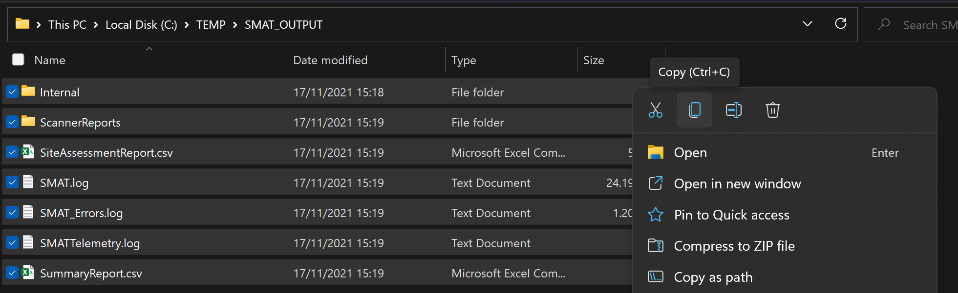

* Navigate to the Power BI package folder > Right-Click here and choose “Paste” -

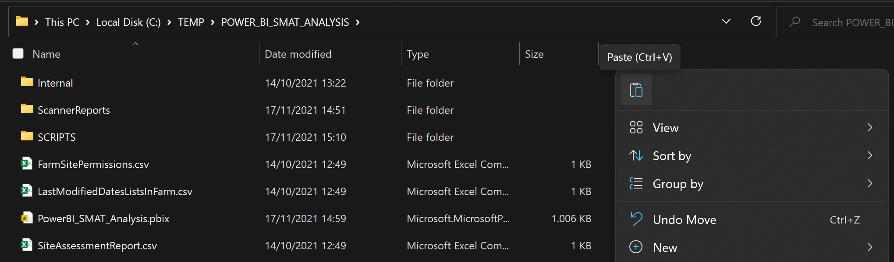

* You should now have a merged location

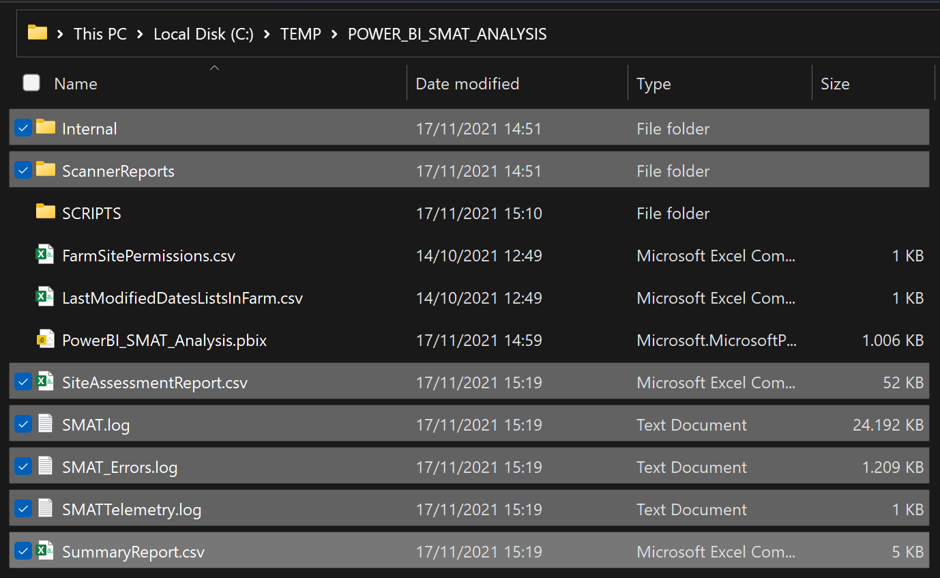

### Update the Report Folder Path parameter in the Power BI settings

* Open the **PowerBI_SMAT_Analysis.pbix** file using the latest version of Power BI Desktop.
* On any page of the Power BI > in the “Home” section of the ribbon > select “Transform Data” > select “Edit Parameters”

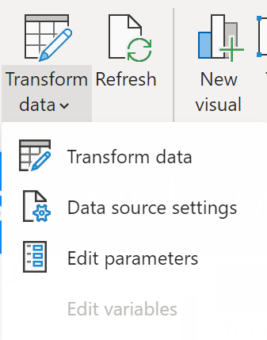

* + You will be presented with a dialog box where you can provide the “new location” of the SMAT output folder – this is just an example, the location can be anything:

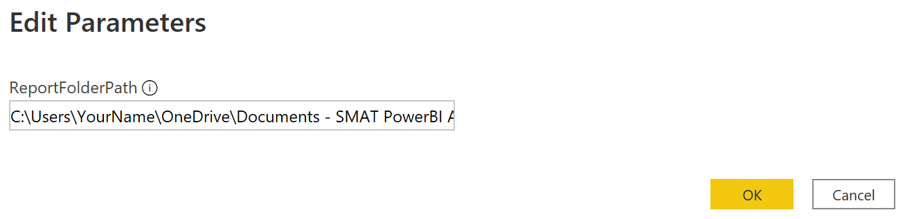

* In the pop-up banner click "Apply Changes" 
* This will start the re-processing of all the relationships

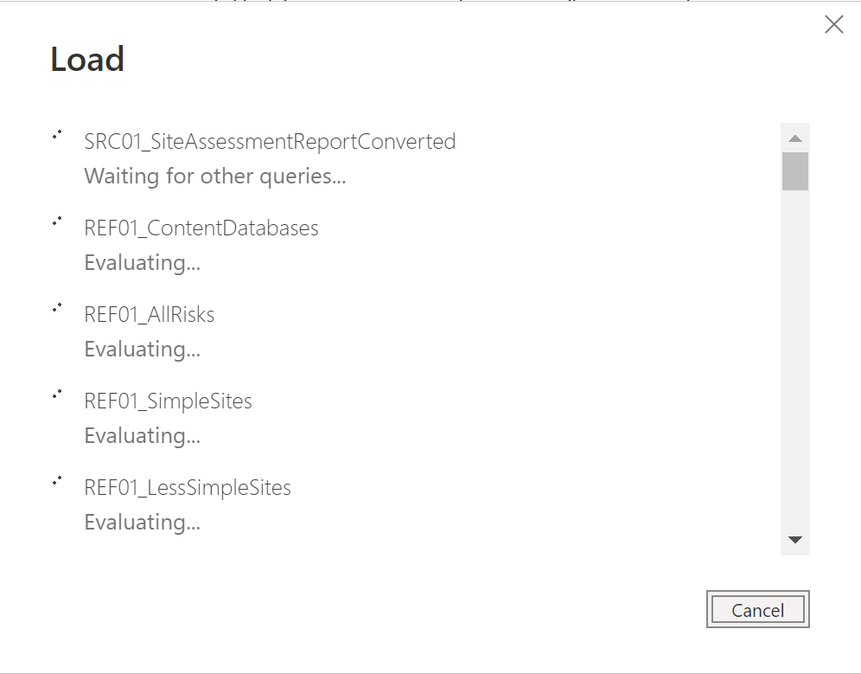

* WAIT… Depending on the size of the SMAT output, this can take a while. Once finished you *should* see the report pages reflecting your content.

## Optional – Run Data Collection Scripts

The Power BI Report contains four *optional* “Report Pages”. For these to work properly, the execution of additional data collection PowerShell scripts is needed. These optional data collection scripts can be found in the SCRIPTS folder of the package.

IMPORTANT: It is recommended to run these scripts *only* after running the SMAT tool, using the same account you used to successfully finish the SMAT data collection.

OR: At a minimum the account that will run the scripts requires “Read Access” to all content. This can be achieved by adding the “account” to the Web Application Policy for all web applications in your farm except Central Admin (for more information see: [link](https://docs.microsoft.com/en-us/sharepoint/administration/manage-permission-policies-for-a-web-application))

### SCRIPT: **ReportLastModifiedDateAllListsInFarm.ps1**

The execution of this script is needed for use of the following optional pages:

WARNING: This script will iterate through all **lists** in all (sub)**webs** in all **site** collections. Depending on the content footprint, this script could take a very long time to complete and consume a lot of memory. Don’t run at the same time as another data collection!

* Dashboard
* Last Modified by Content
* Last Modified by Date

NOTE: (If needed) In the “static variable(s)” region of the script you can view/change which lists should be excluded during the iteration of your content – **hidden lists are excluded by default.**

After execution of the script, you will find a report file called “LastModifiedDatesListsInFarm _FarmID_YYYYMMDDHHMMSS.csv” in the directory you specified as parameter when launching the script.

IMPORTANT: Rename the generated output file to “**LastModifiedDatesListsInFarm.csv**” and copy the file into the root SMAT folder (same location where the Report Folder Path parameter points to).

### SCRIPT: **ReportPermissionAllWebsInFarm.ps1**

The execution of this script is needed for use of the following optional pages:

WARNING: This script will iterate through all (sub)**webs** in all **site** collections. Depending on the content footprint, this script could take a long time to complete and consume a lot of memory. Don’t run at the same time as another data collection.

* Web Owners Overview

After execution of the script, you will find a report file called “FarmSitePermissions_YYYYMMDDHHMMSS.csv” in the directory you specified as parameter when launching the script.

IMPORTANT: Rename the generated output file to “**FarmSitePermissions.csv**” and copy the file into the root SMAT folder (same location where the Report Folder Path parameter points to).

## Tips for navigating the Power BI Report

TIP2: Some pages have a button on top that looks like the image below, this is meant to be used for clearing all selections made as it can sometimes get difficult to trace what items might still be selected across multiple slicers.



Hold down [CTRL] and click on the button to revert the “Report Page” back to its bookmarked state.

**TIP 1**: There are many “Report Pages” in this Power BI Report. You can [right-click] on one of the navigation arrows in the bottom left of Power BI Desktop and see a list of all available pages:

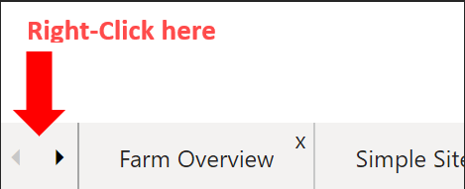

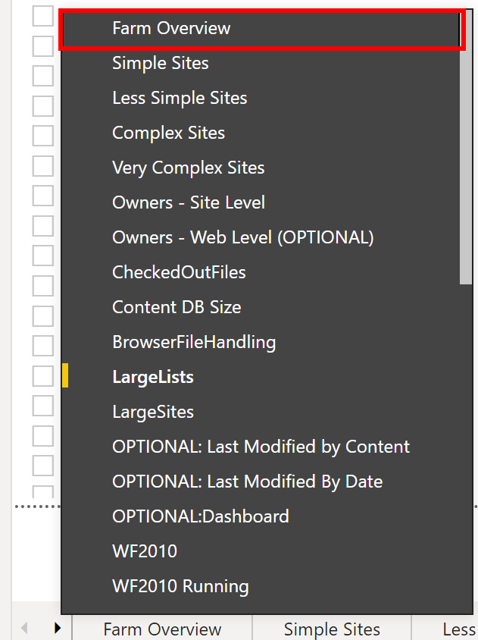

* Simply click one of the “entries” and you’ll jump straight to that report page.

## Overview of “Report Pages” in the Power BI Report

### SMAT Overview

As the name implies this report page shows a high-level overview of the number of Sites, Webs, Items and Issues for the entire farm. When selecting a specific Web Application or Site Collection, values are updated limited to the selected scope. 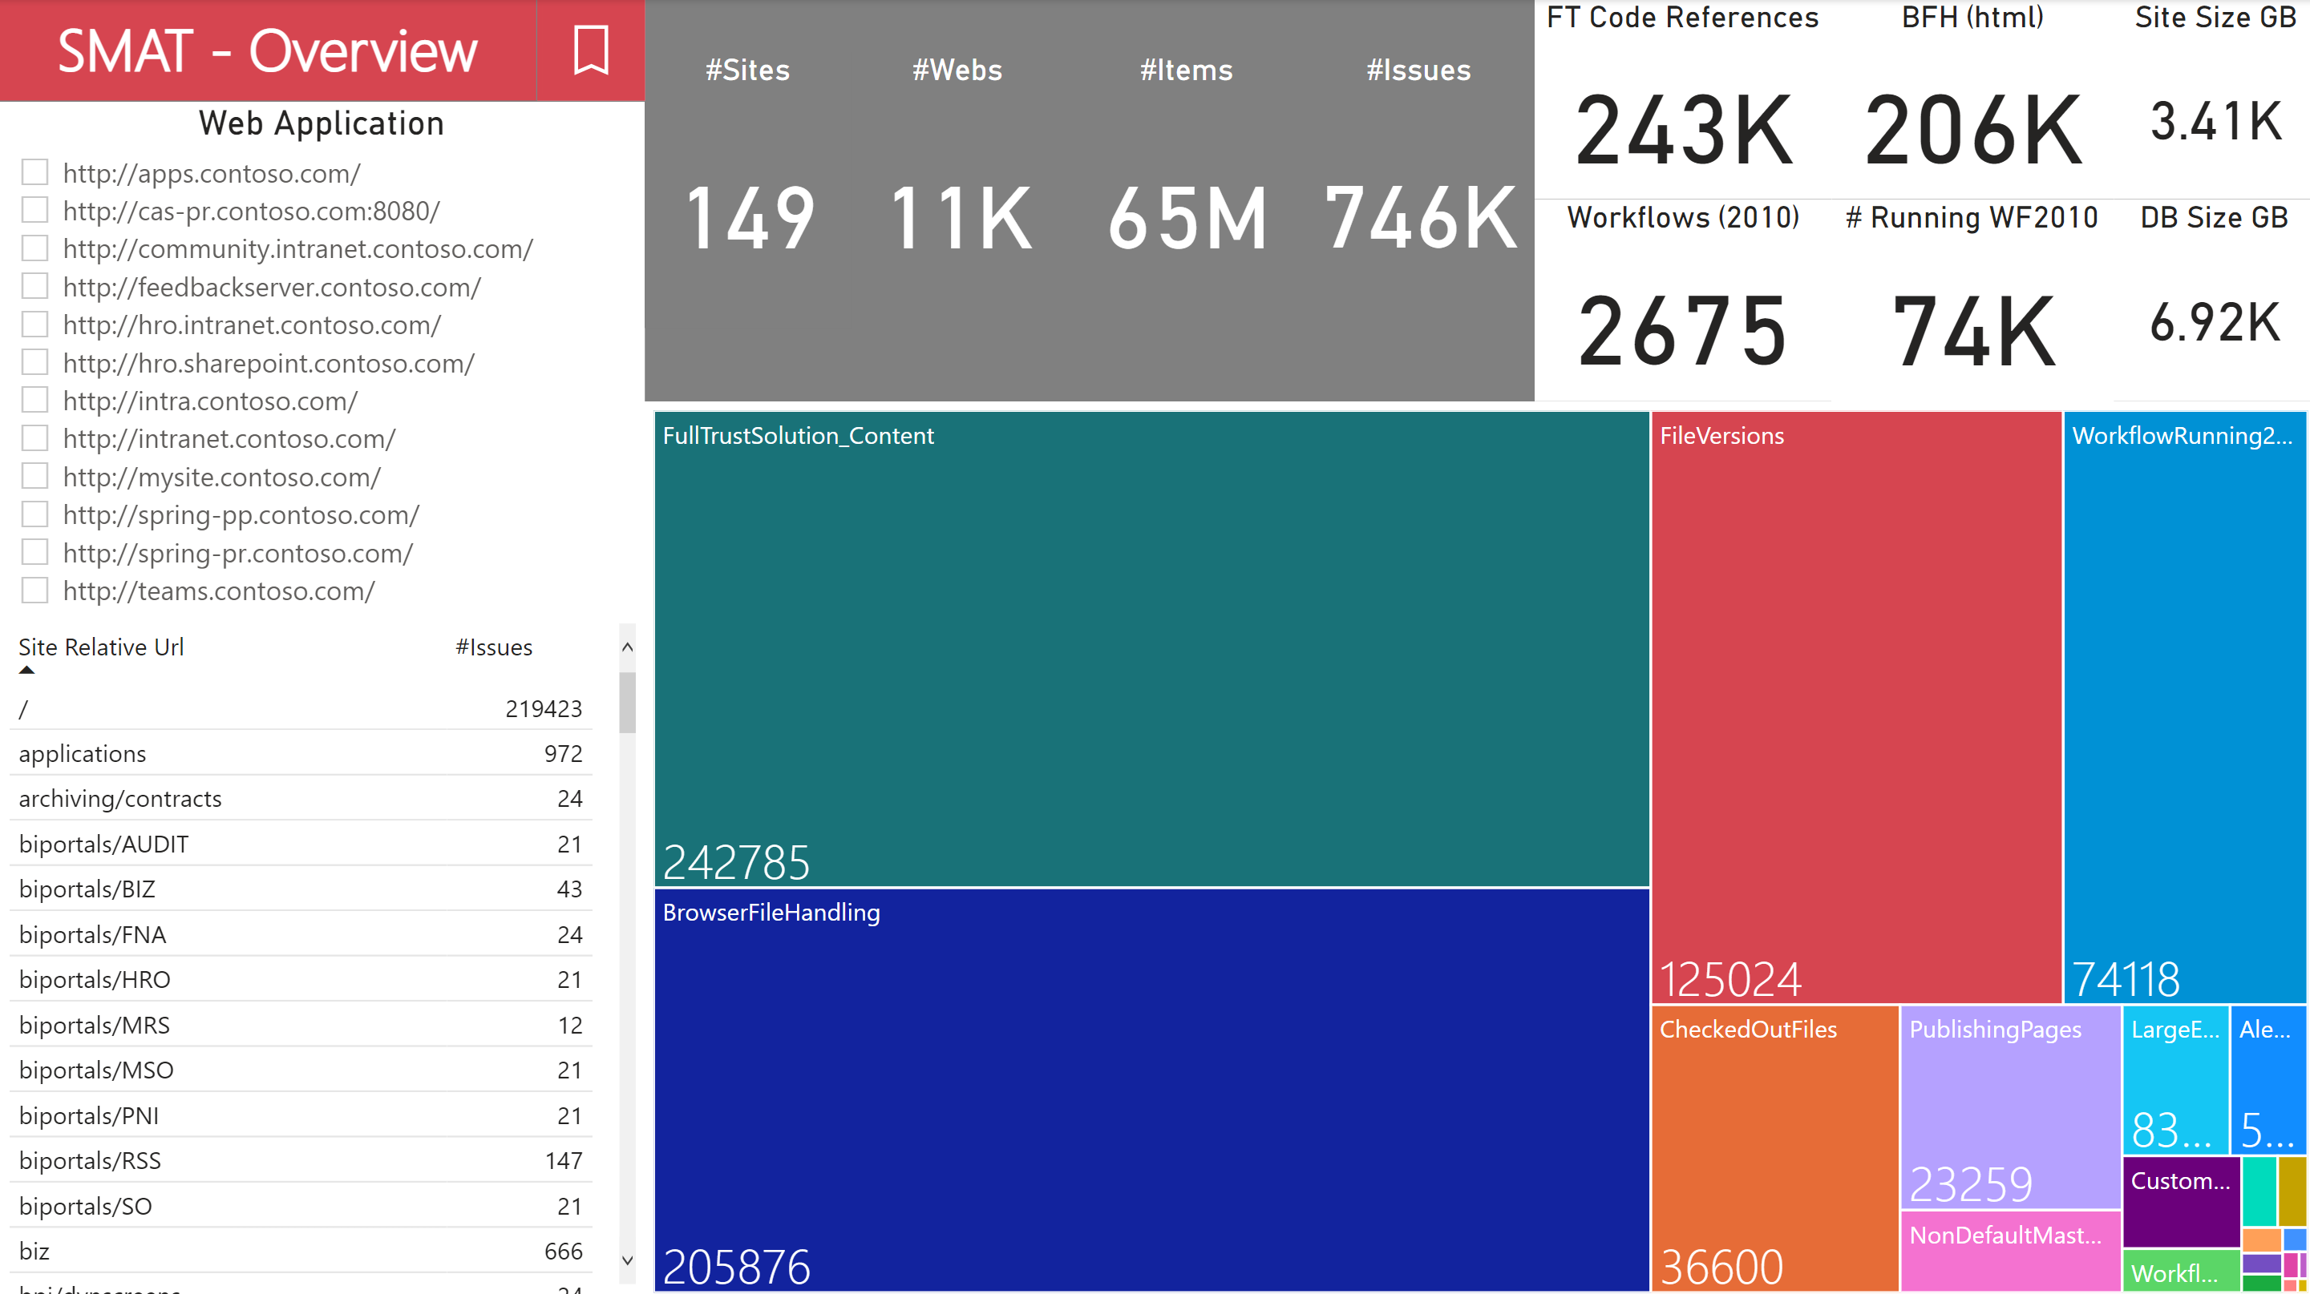

### Simple Sites

NOTE: To try and categorize site collections into four easy to understand “migration complexity” buckets, we decided to use a single parameters to make the split. We’re currently only taking the total amount of “Issues” into account. This might not correctly represent every organization situation, but we needed to have a generic guideline.

“Issues” can be anything from a simple *checked out file*, to a complex custom code feature that is providing key functionality to the organization. The first one is easily “checked in” again, the custom code will be a different story.

However “Sub Webs” should also be considered here, because Microsoft preaches to create site collections with a root web only, avoiding “Sub Webs” as much as possible.

This would mean that a single classic site collection with a hierarchy of 20 “Sub Webs” could potentially be migrated to 20 modern site collections. It’s also possible that some “Sub Webs” were created to host one (or more) “pages” which could be replaced by merging the pages to a single site collection and *creating modern navigation to reflect the former “hierarchy”.*

NOTE: Any “Workflow 2013” Issues are not shown in the graph on the first 5 report pages, but are counted in the #Issues!

**Simple Sites** | <50 Issues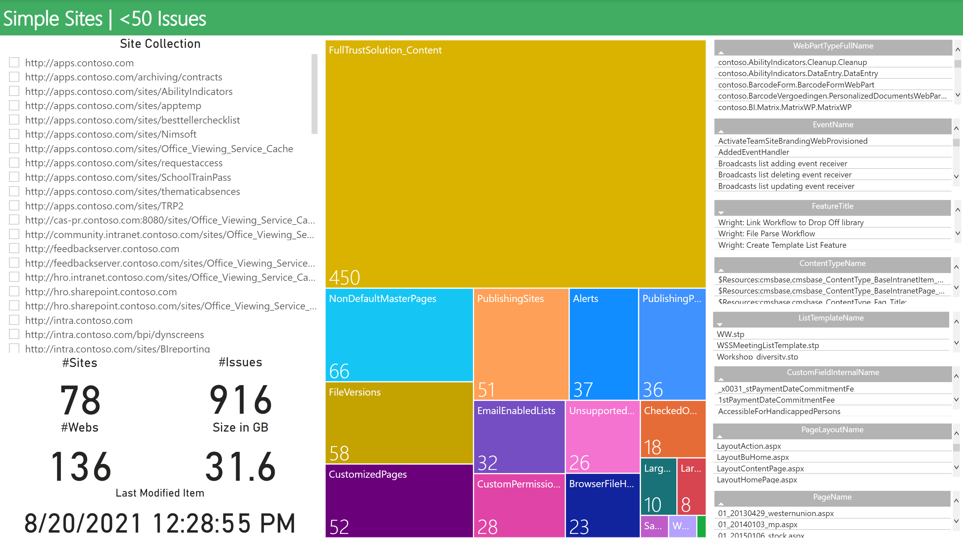

### Less Simple Sites

**Less Simple Sites** | 50 - 499 Issues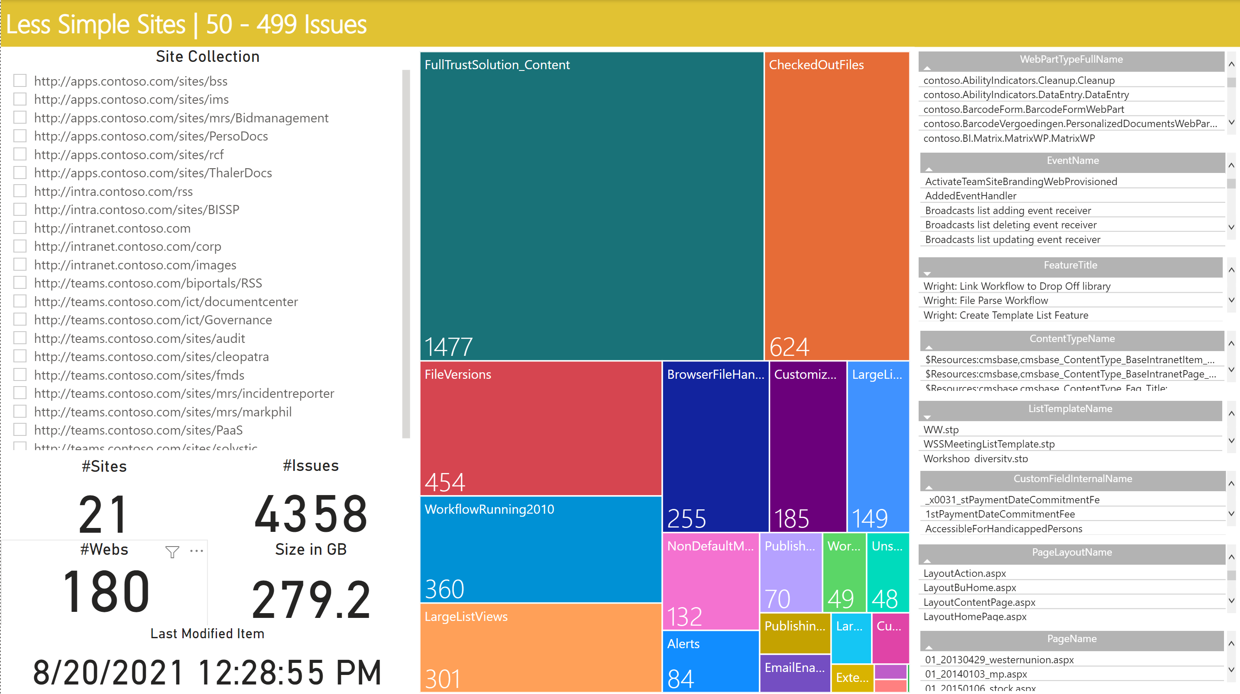

### Complex Sites

**Complex Sites** | 500 - 4999 Issues 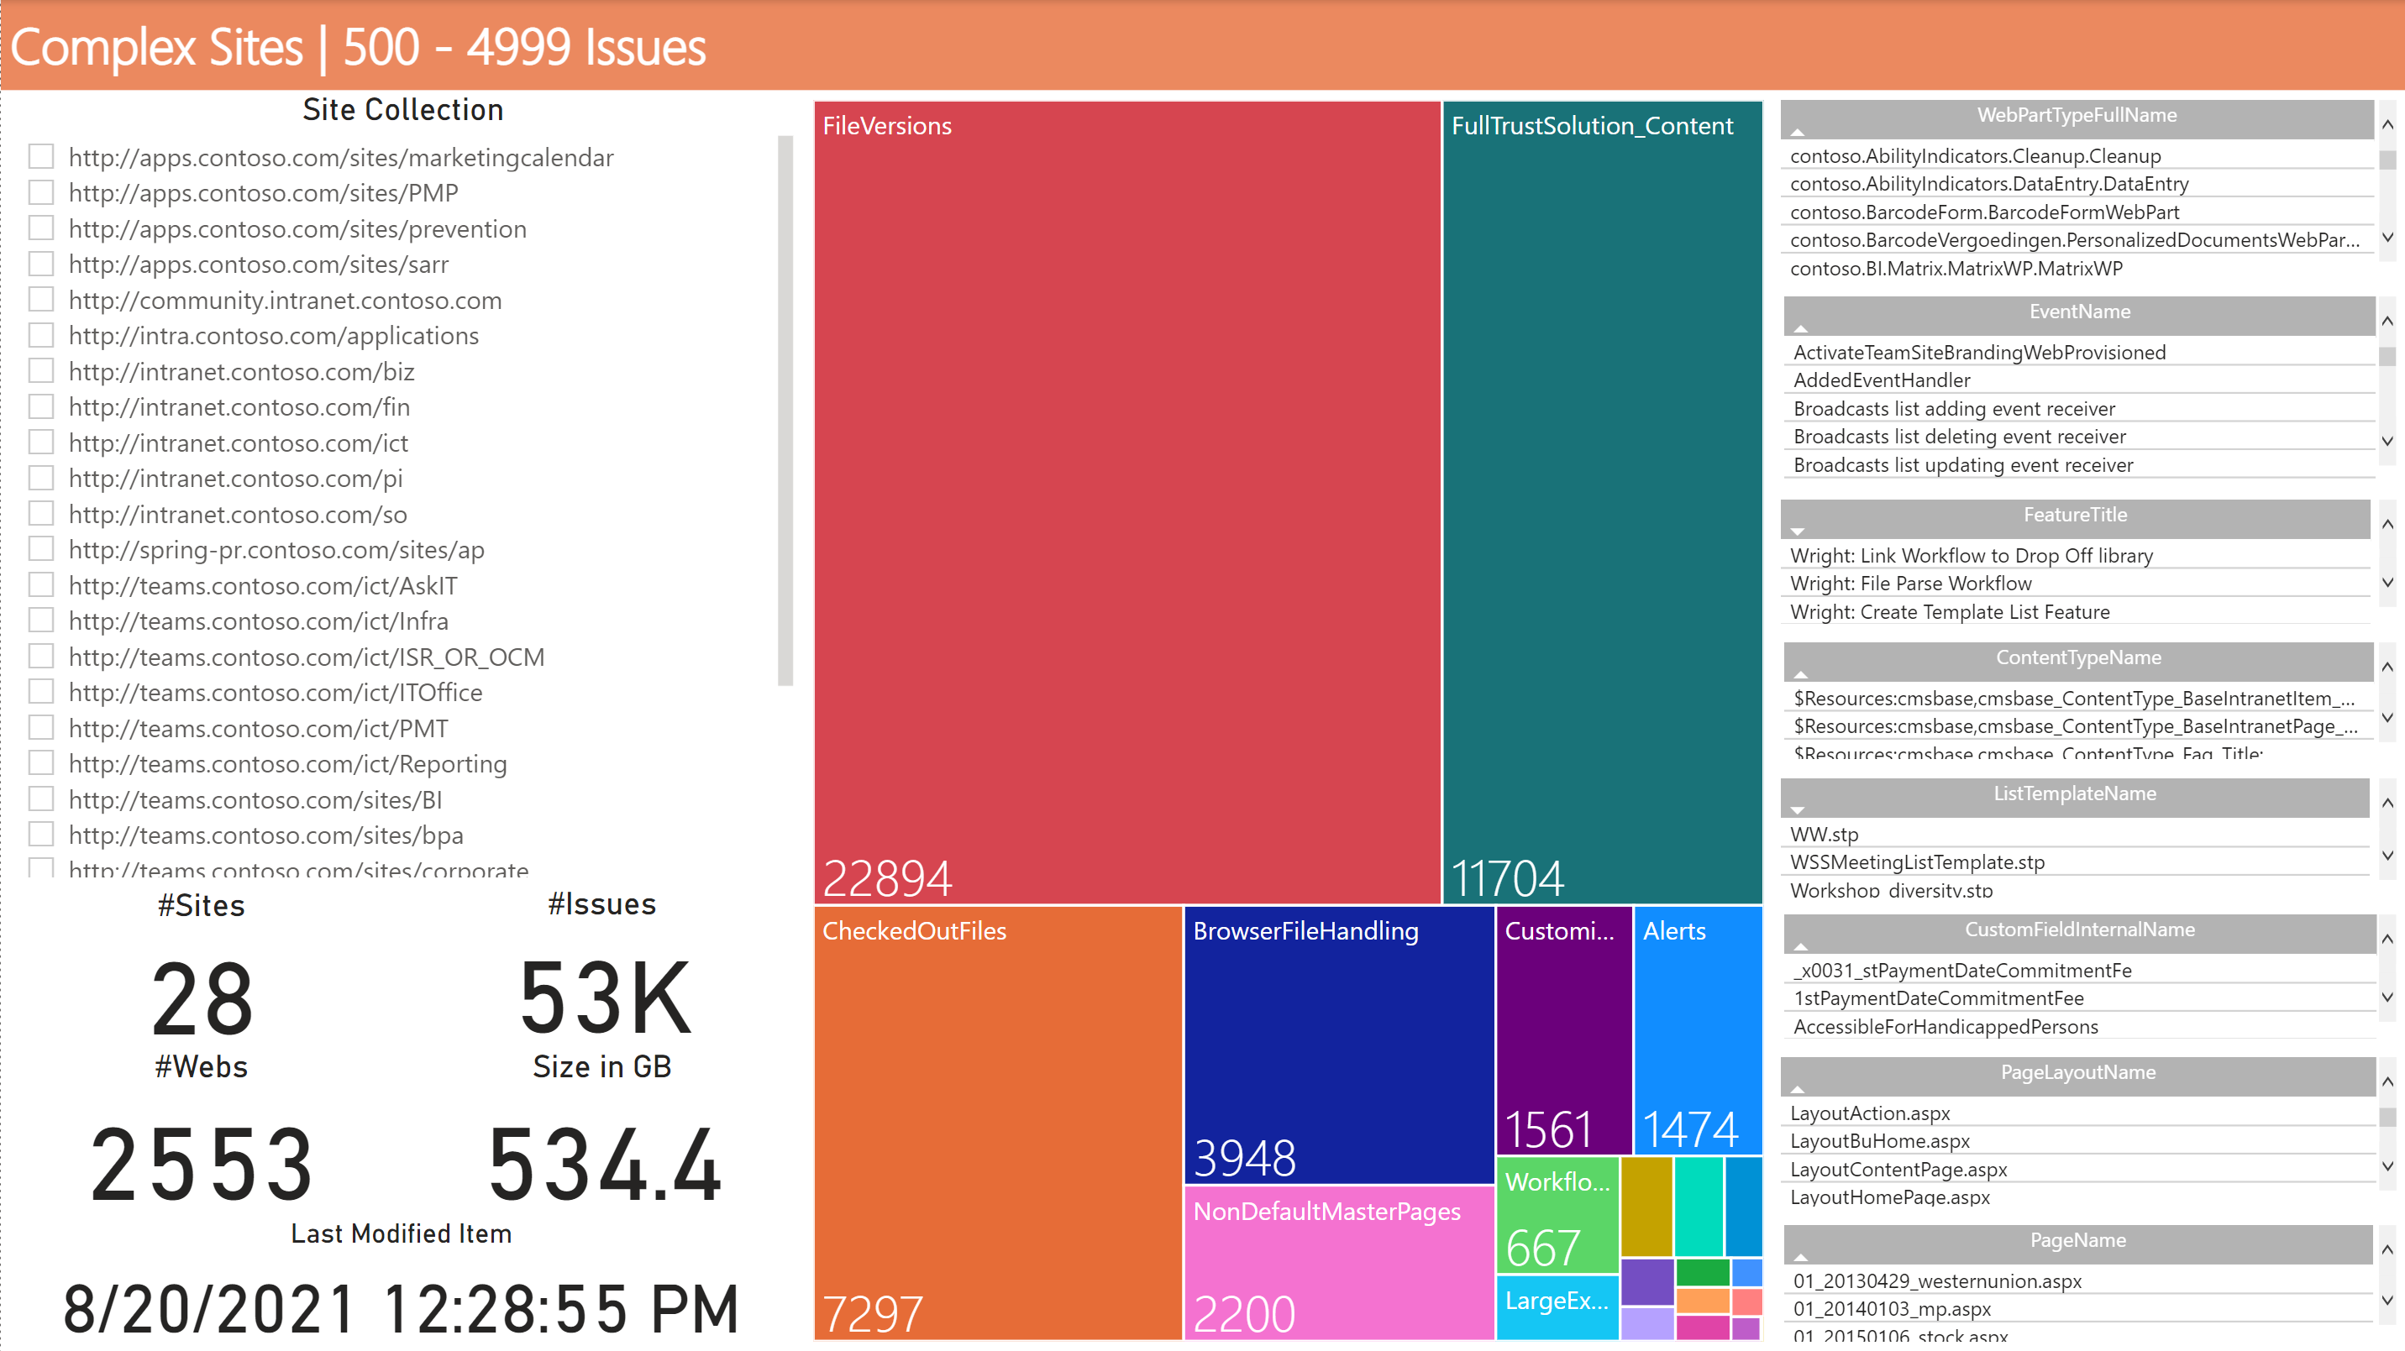

### Very Complex Sites

**Very Complex Sites** | 5000+ Issues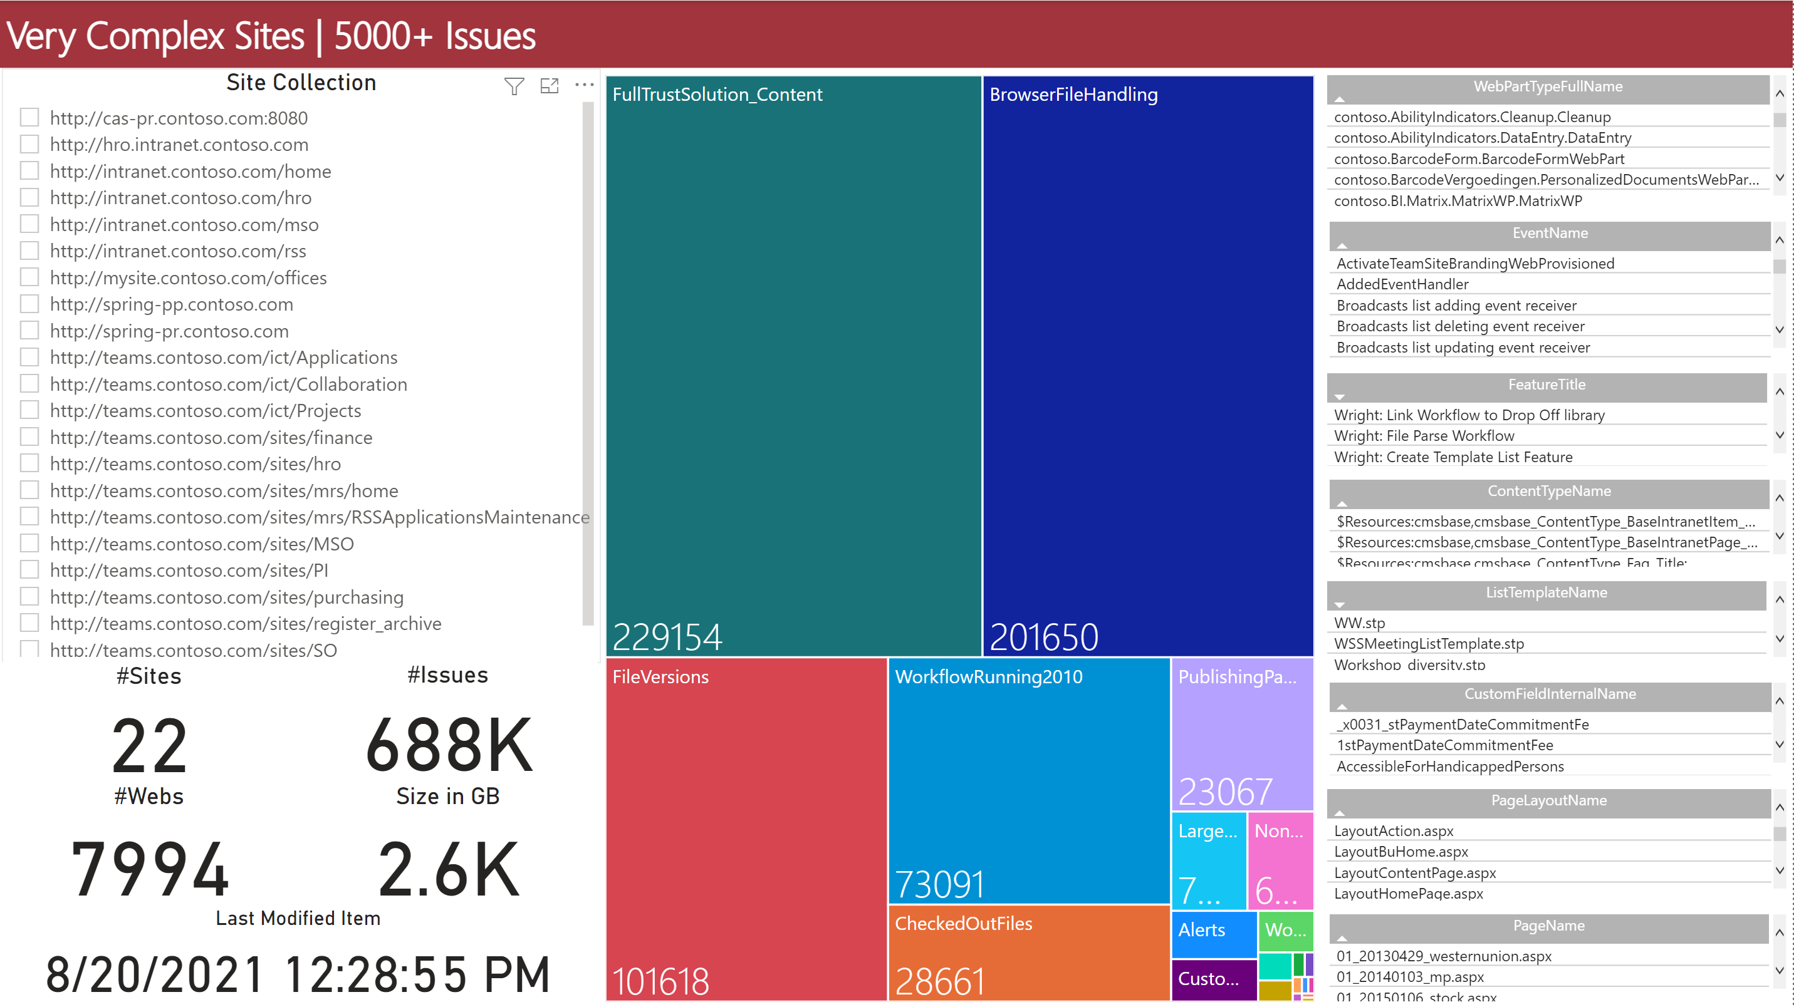

### Site Owners Overview

Provides a drill-down of the site collection administrators, with separate indication of the “primary admin”. This should help with identifying the “Owners” of the site collection. 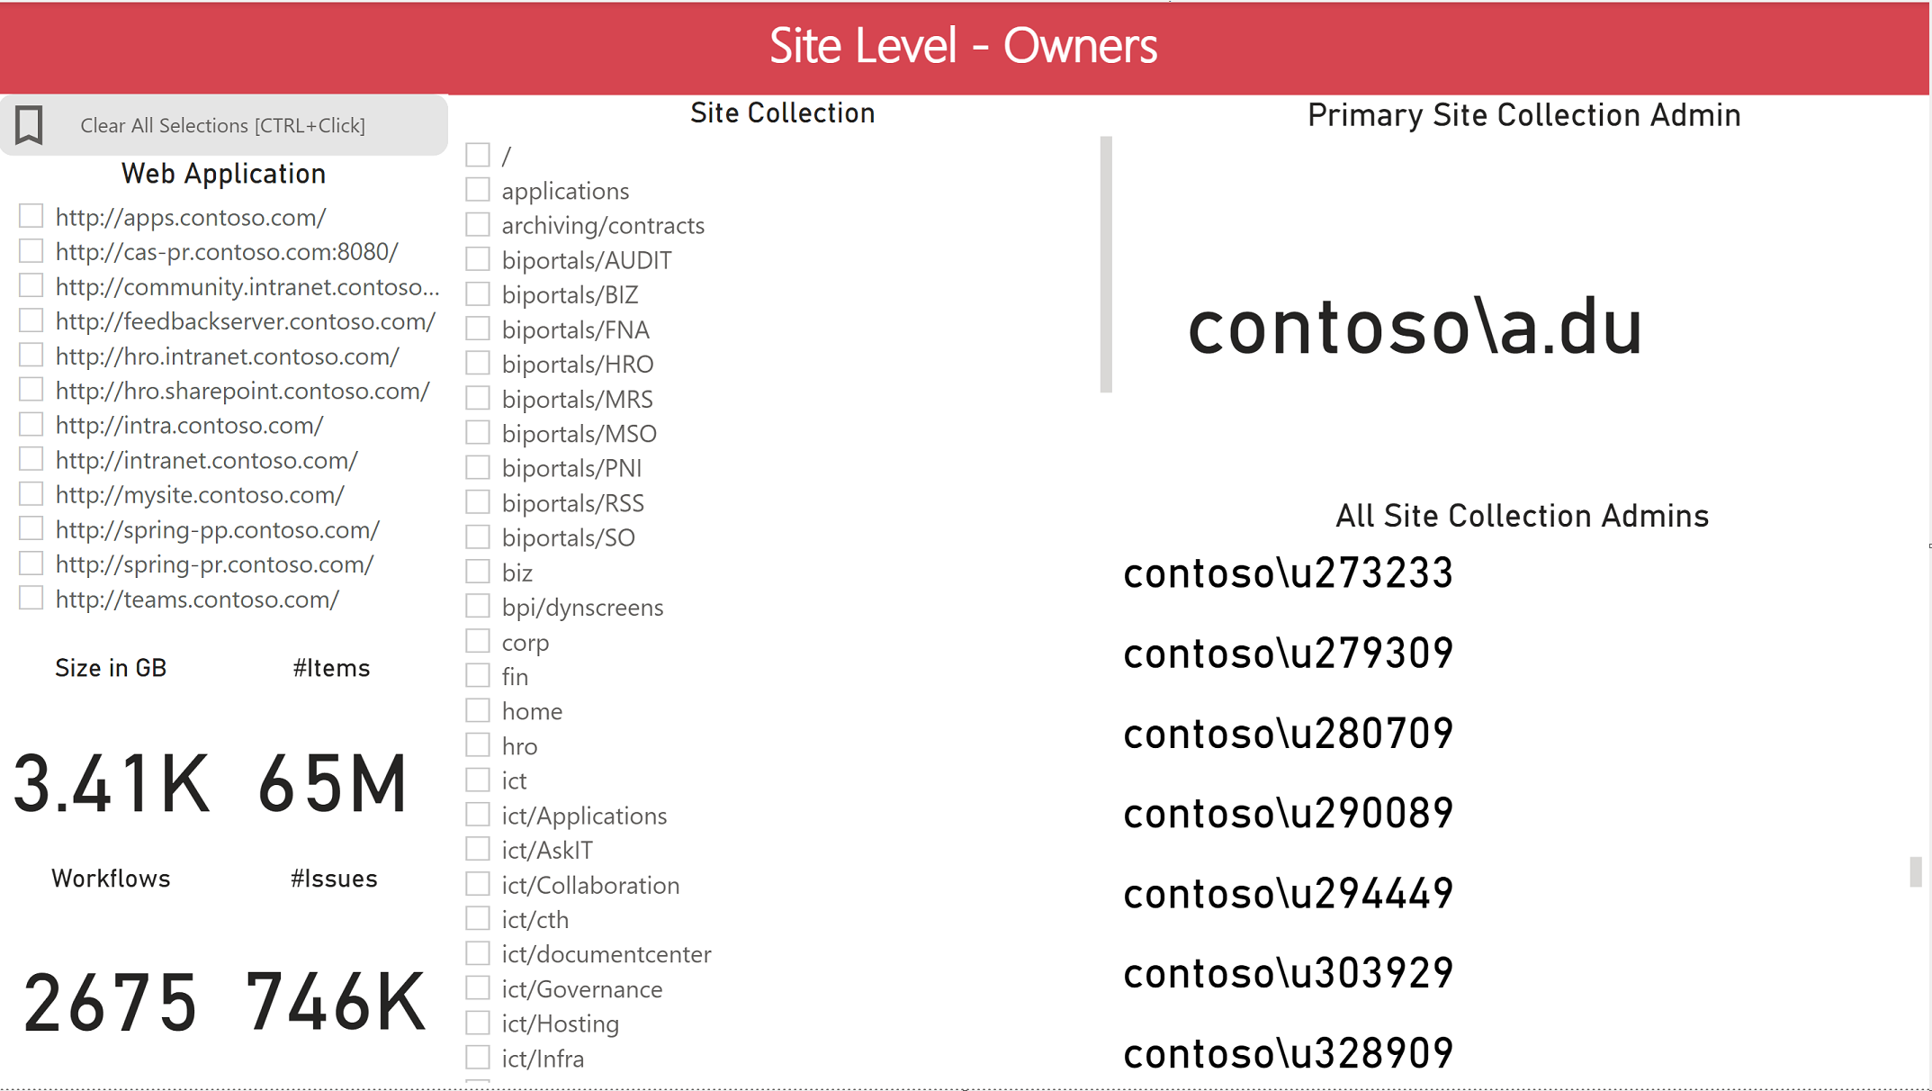

### Checked Out Files

Provides an overview of checked out files “by user” – across all web applications and site collections in the farm.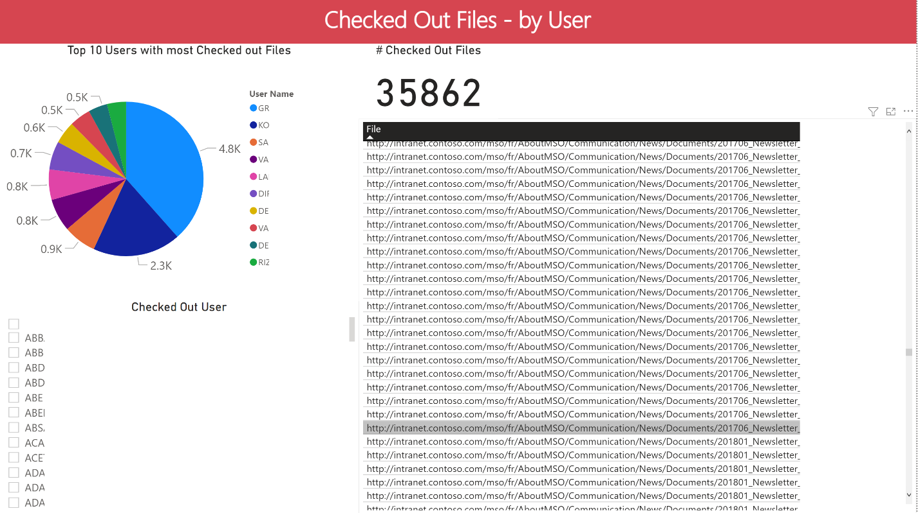

### Content DB Size

Very straight forward overview of the content database properties, with drill down on web application level.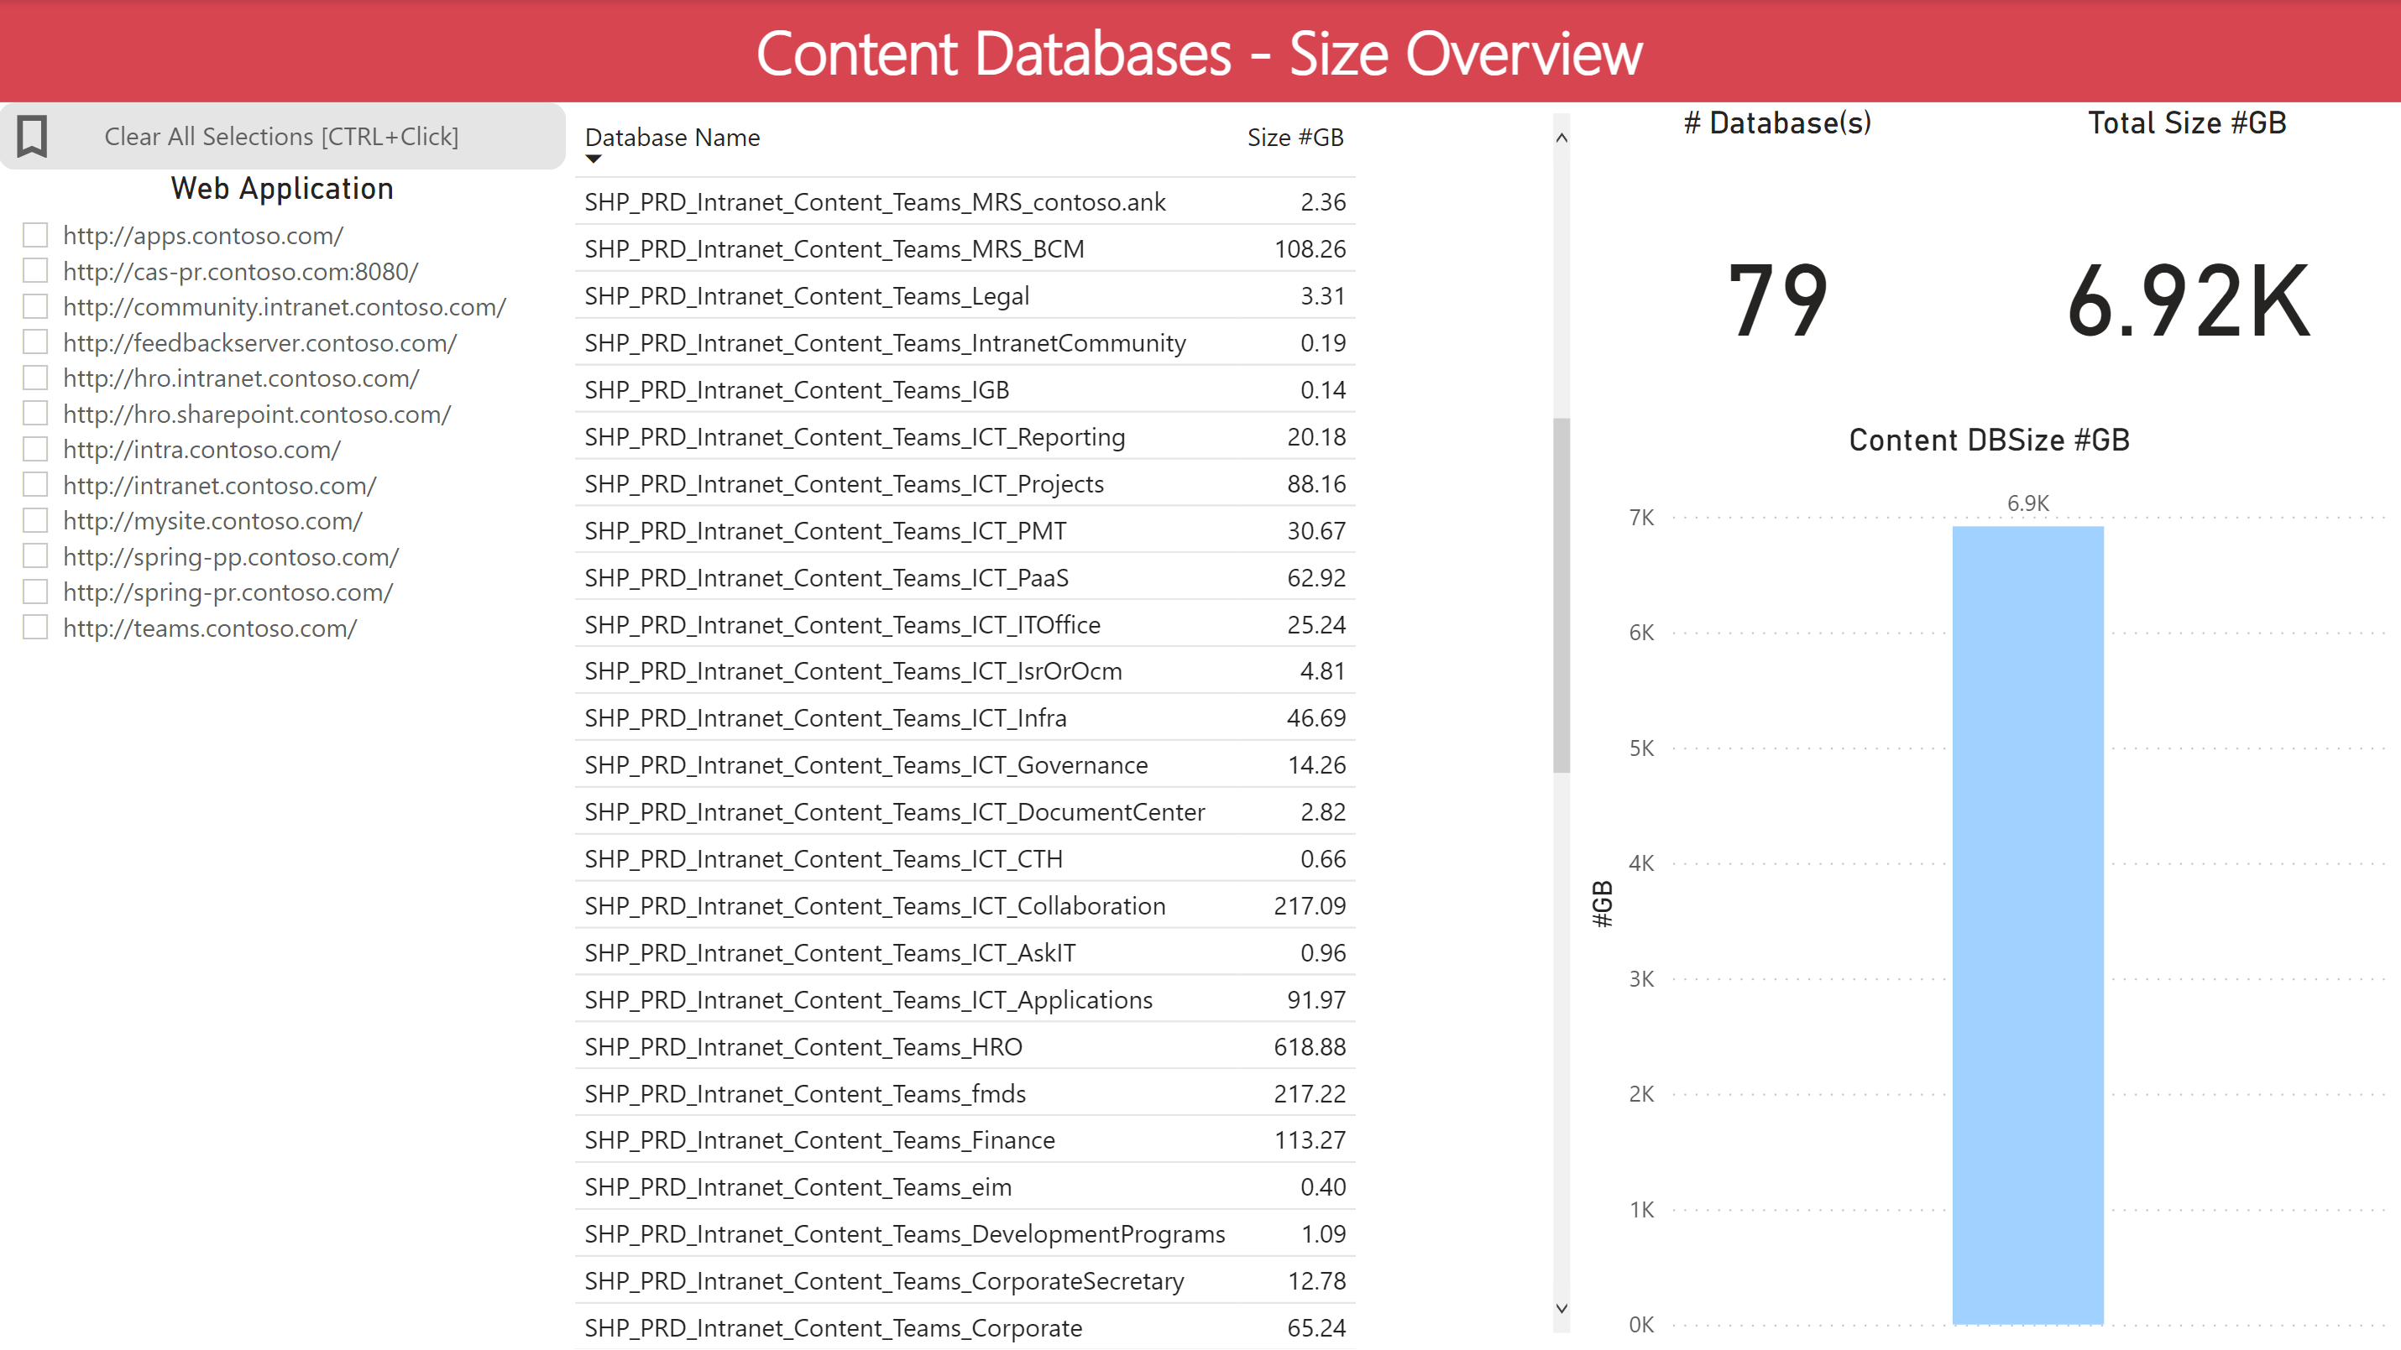

### Browser File Handling

Issues about files that are not rendered in SharePoint online, such as .html files. Drill down report to site collection level, providing a total for the scope and full list of files and last modified by information.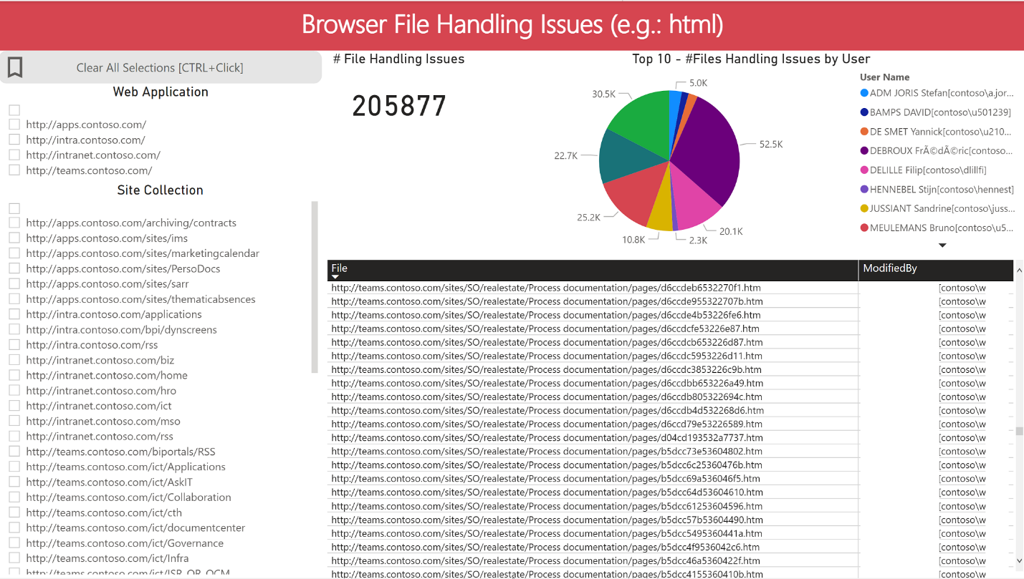

### Large Lists

Provides a drill down of web applications and site collections that contain lists with more than 5000 items. 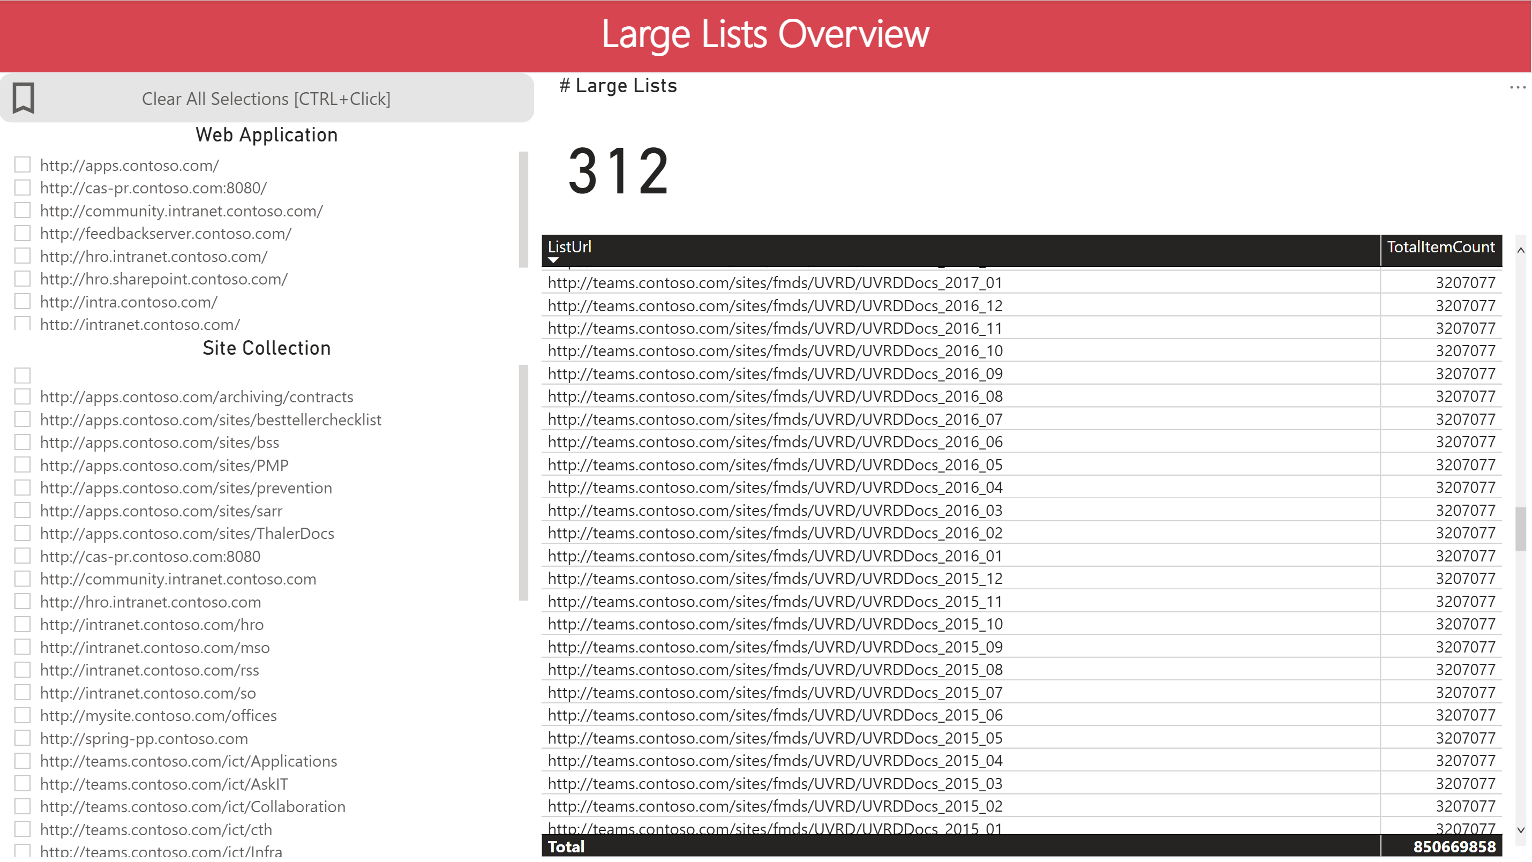

### Large Sites

Provides a drill down of site collections that are larger than 500GB (in this example there is only one)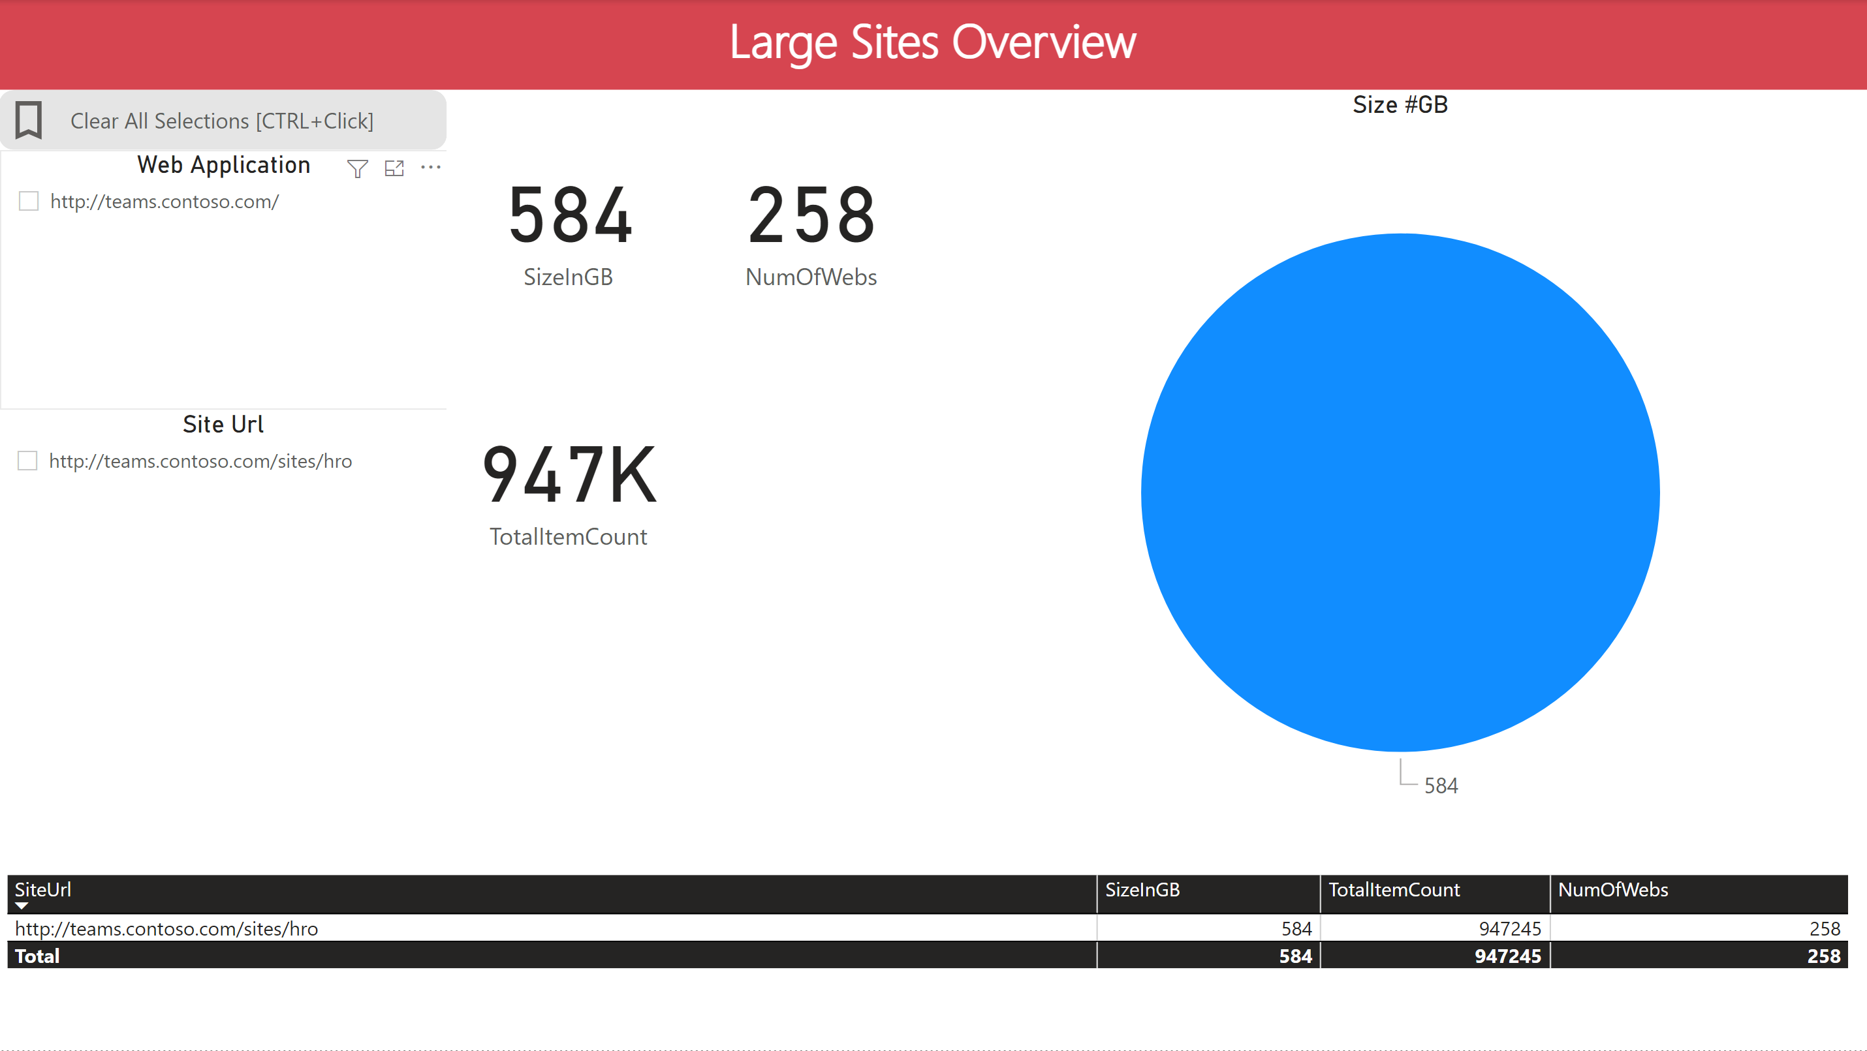

### Workflows 2010

Drill down of 2010-Mode Workflows defined by “scope” (Site/List/ContentType)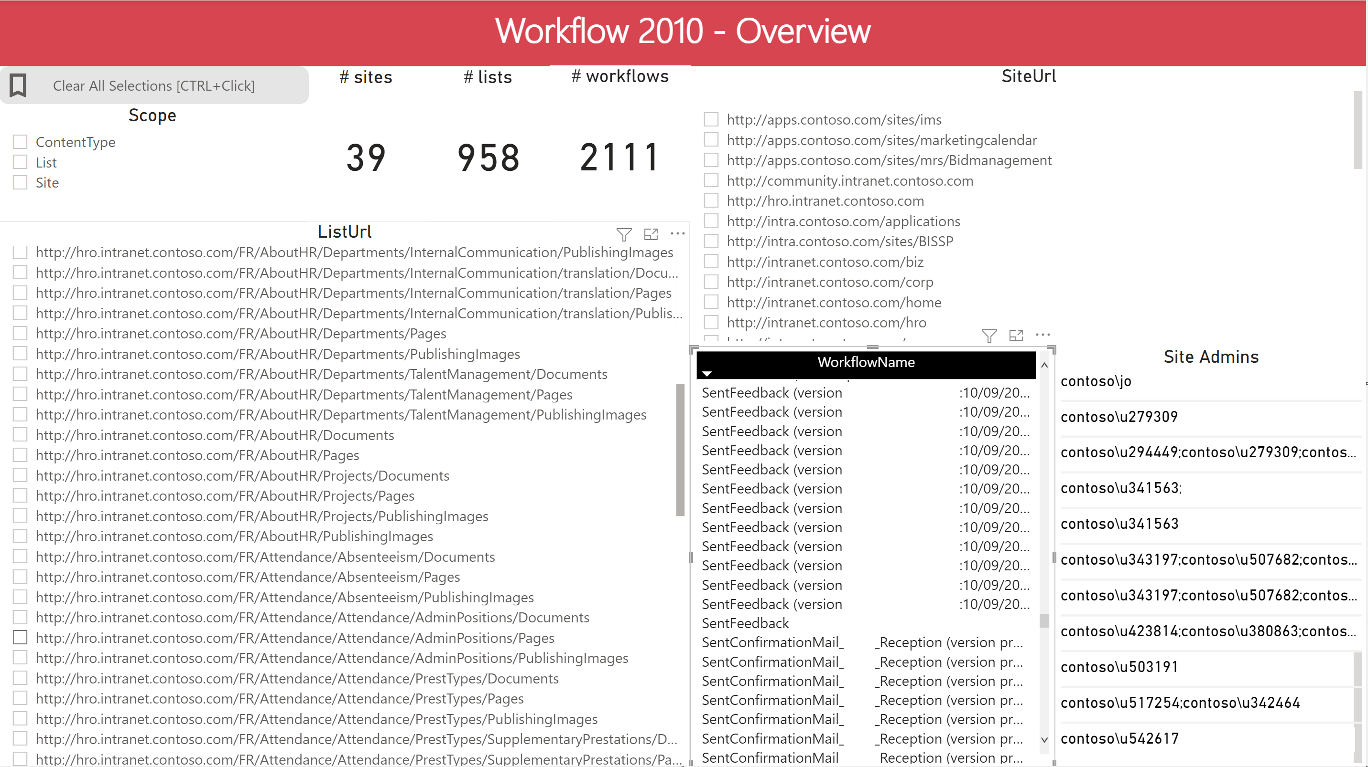

### Workflow 2010 Running

Drill down of 2010-Mode Workflows currently “running”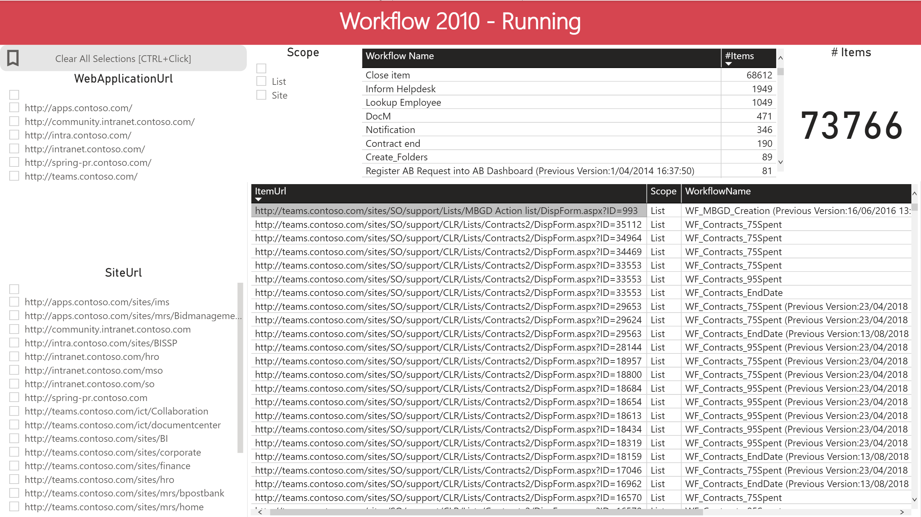

### Workflows 2013

Drill down of 2013-Mode Workflows defined by “scope” (in this example there were no 2013-Mode Workflows defined) 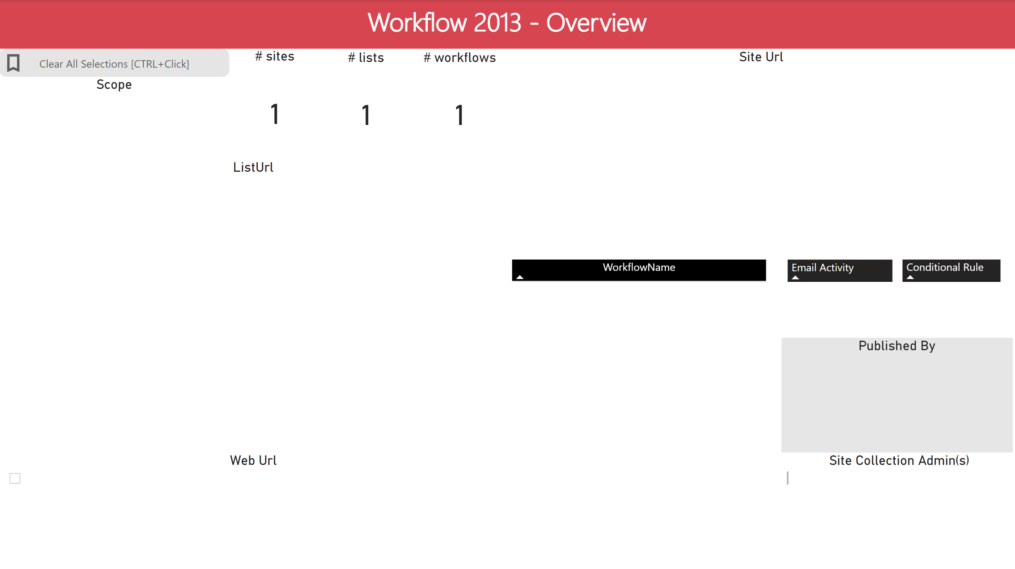

### Workflow 2013 Running

Drill down of 2013-Mode Workflows currently “running” (in this example there were no 2013-Mode Workflows defined)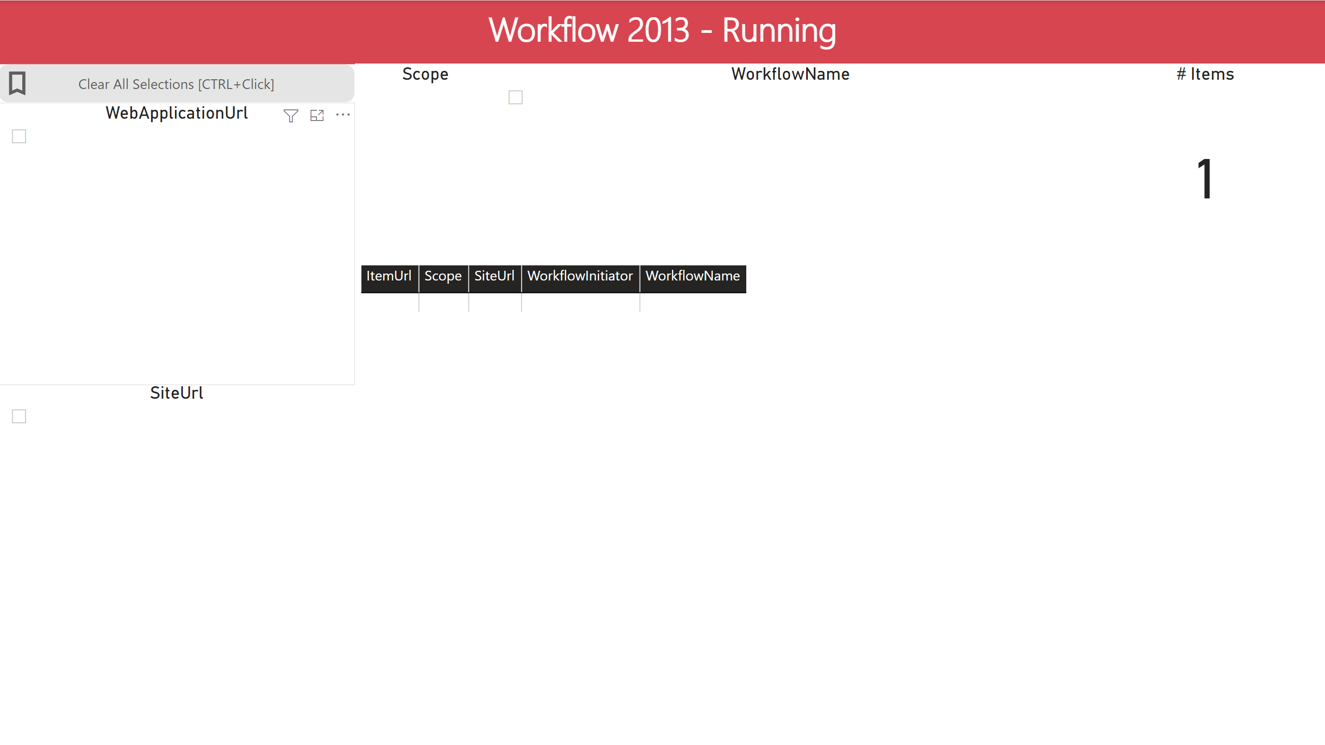

### Apps (Add-Ins)

Drill down of the apps (add-ins) deployed on the farm. 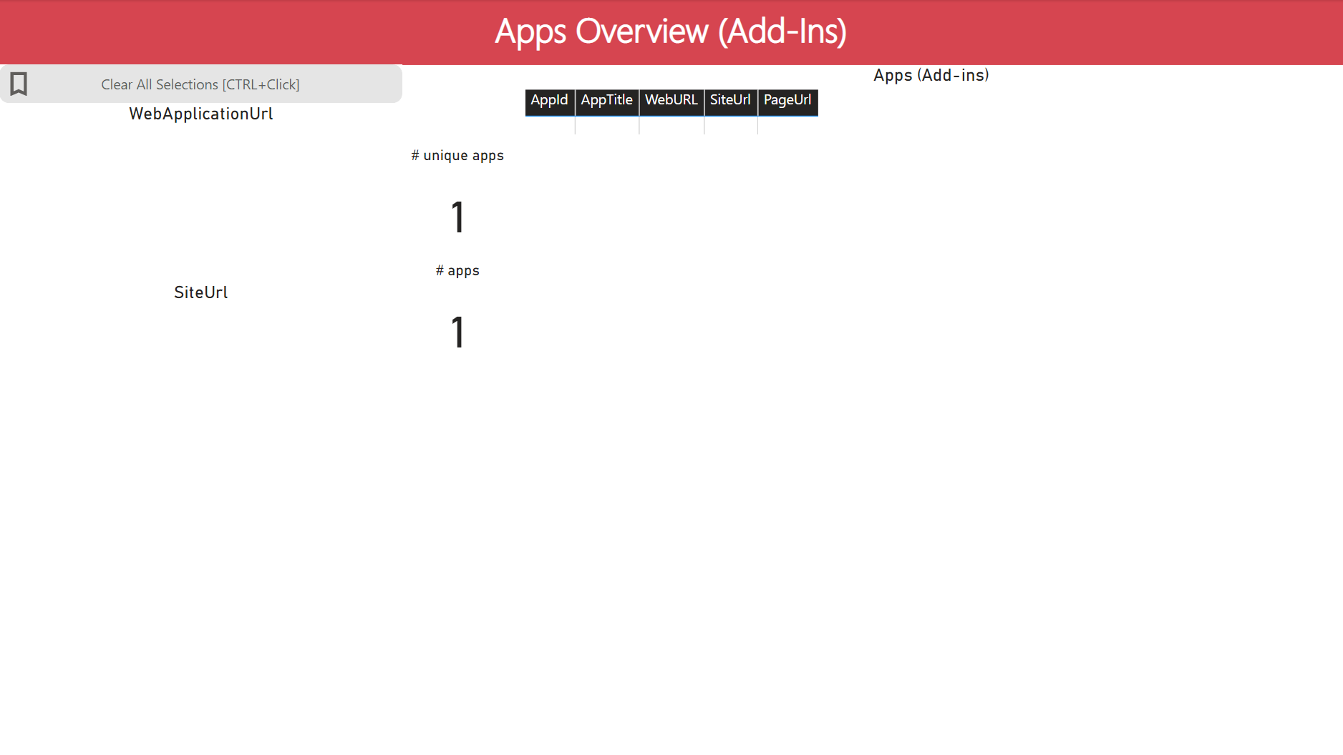

### Full Trust Solutions – Site Features and Event Receivers

Drill down of the full trust solutions deployed on the farm. This report covers the site features and event receivers deployed. Additional filters are available for feature scope.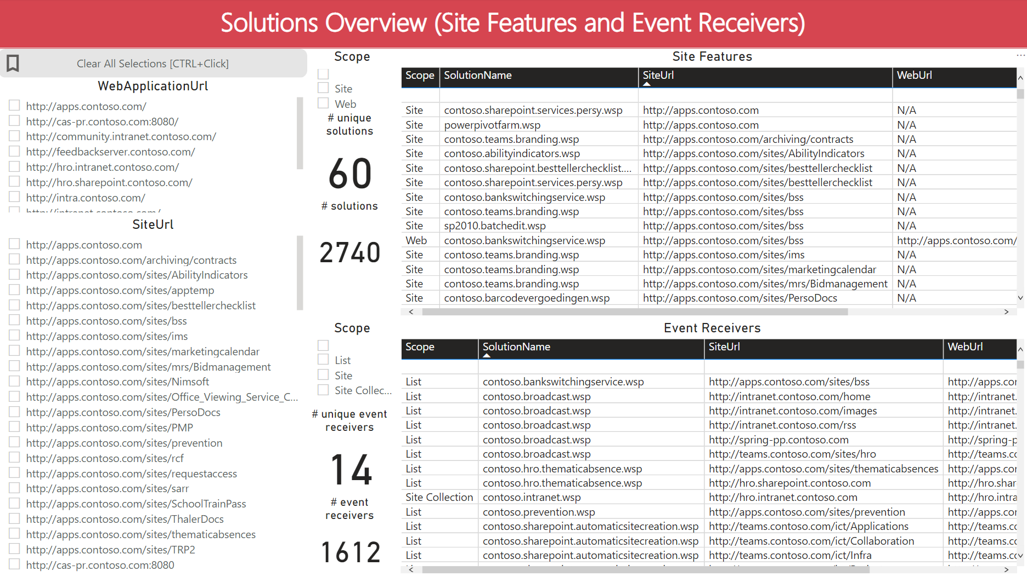

### Full Trust Solutions – Web Parts

Drill down of the full trust solutions deployed on the farm. This report covers the web parts deployed. 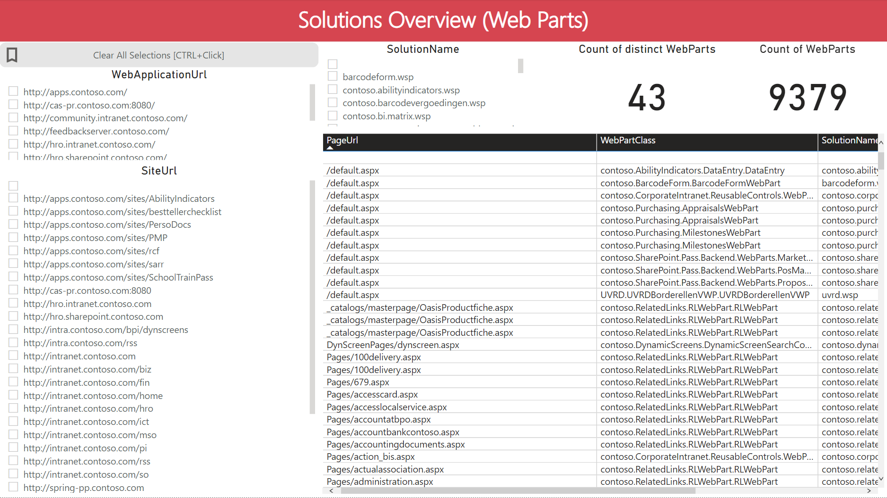

### Full Trust Solutions – Event Receivers on Content Types

<To be completed – Waiting on input files>

### Sandbox Solutions

Drill down of the sandbox solutions deployed on the farm.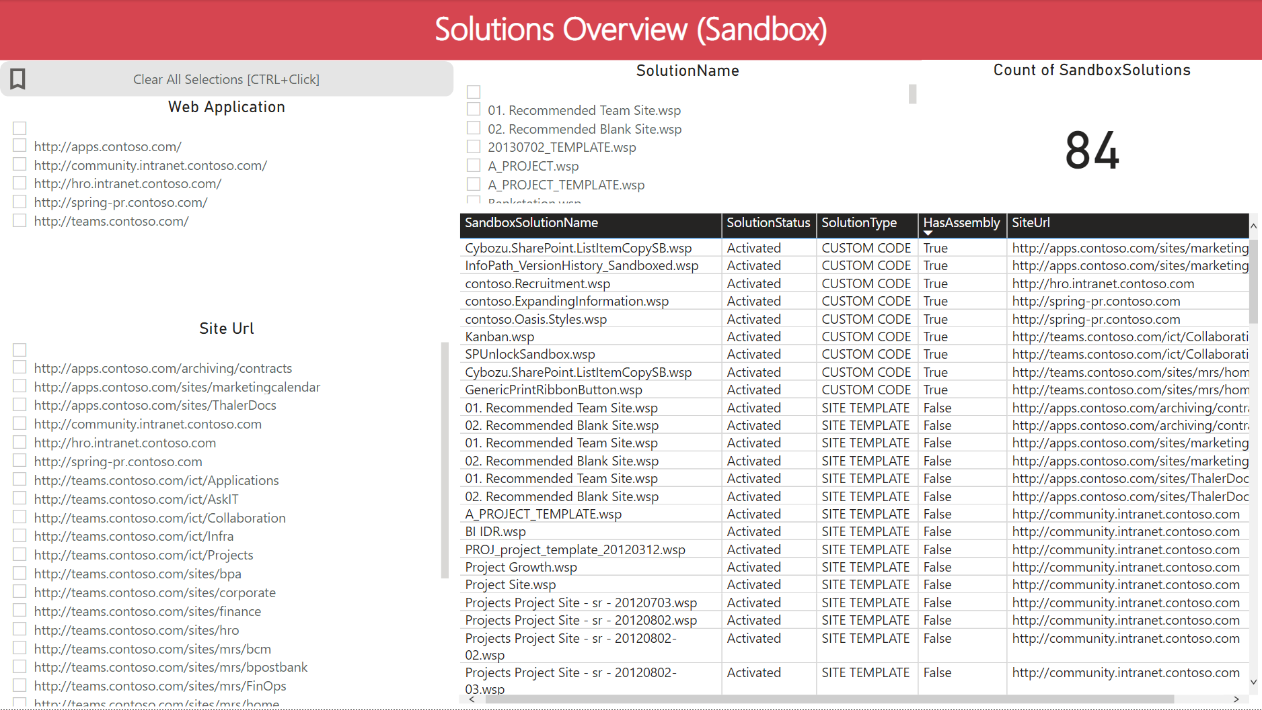

### Business Connectivity Services (BCS)

This report provides details about the usage of BCS in the farm. An overview is provided of external lists (using BCS data) and the BCS application definitions.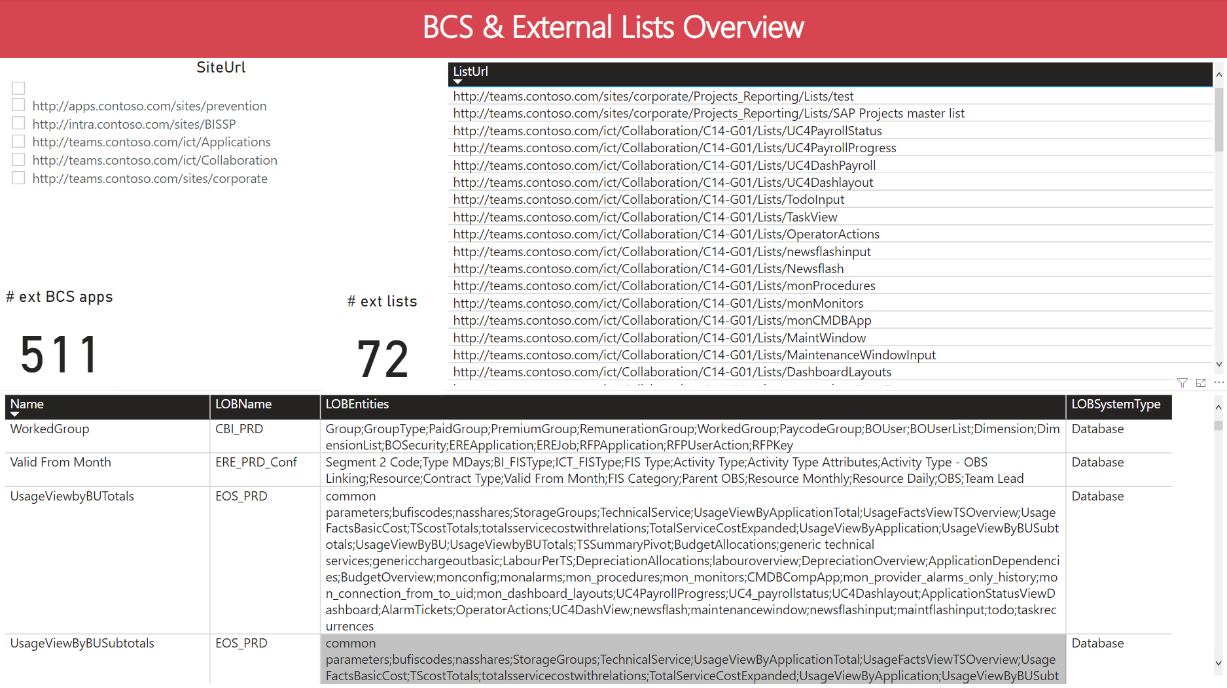

### Secure Store

This report provides details about the usage of the Secure Store in the farm. An overview is provided of the configured applications in the farm.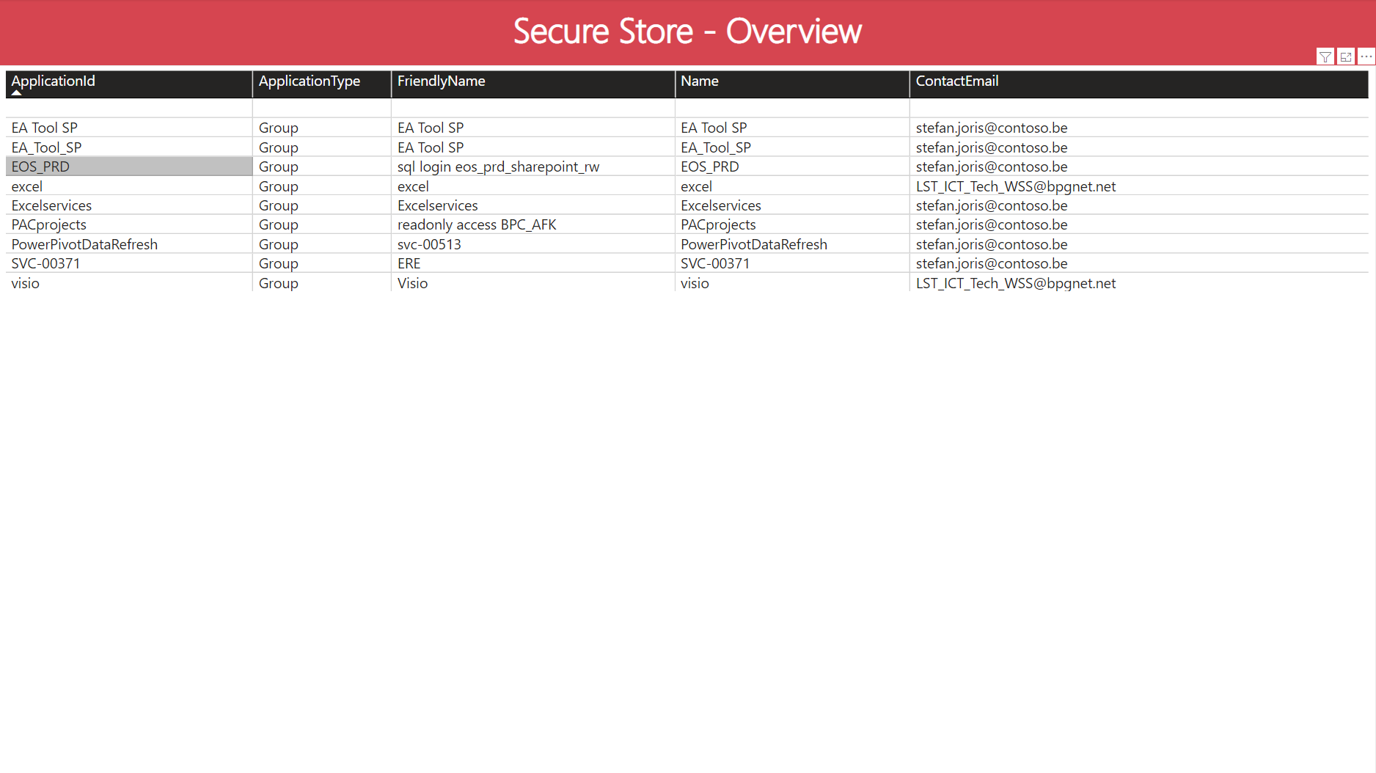

### InfoPath

This report provides details about the usage of InfoPath forms in the farm.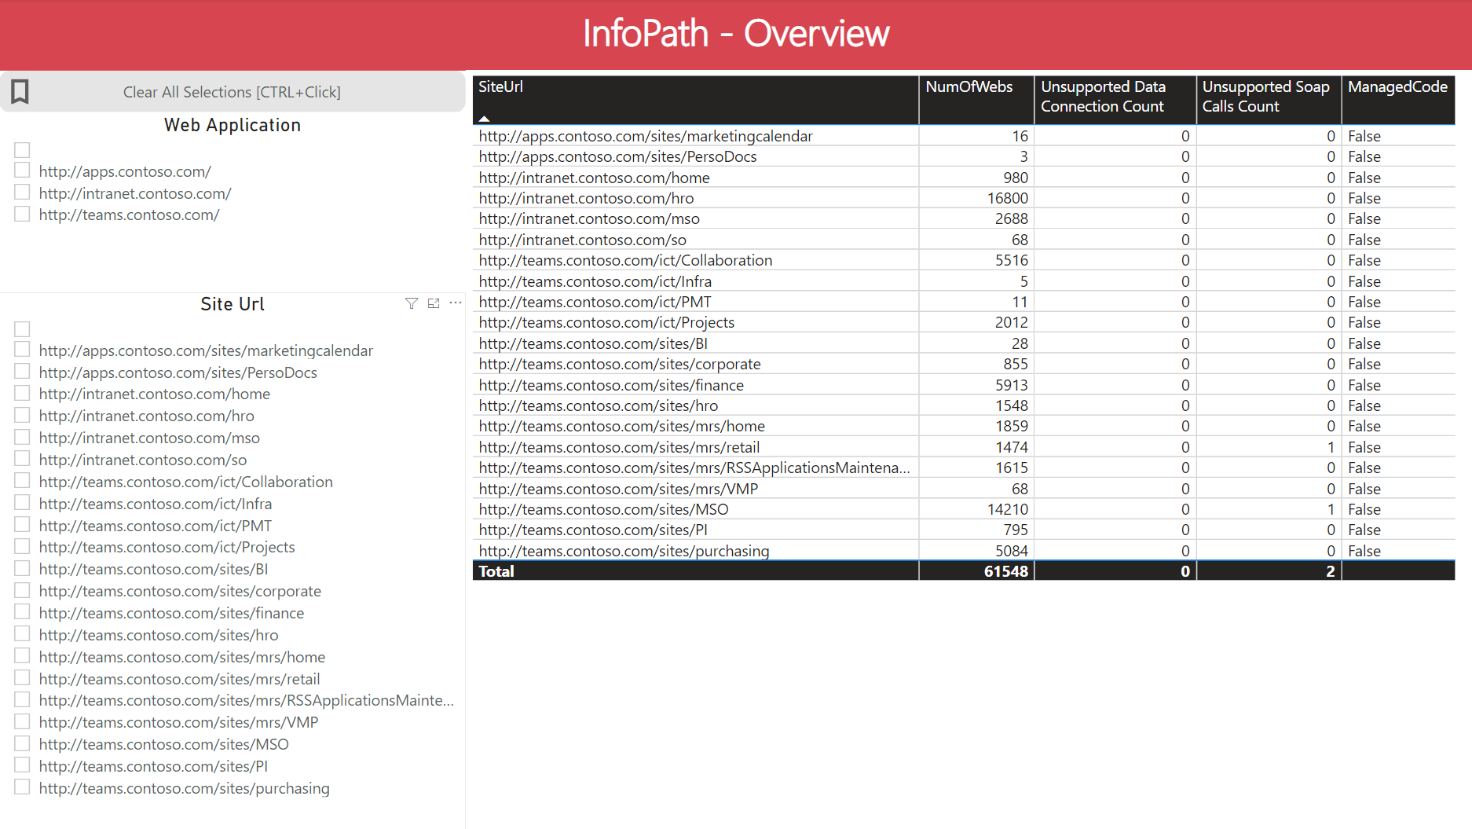

### Email Enabled Lists

This report provides details about the usage of the email enabled lists in the farm.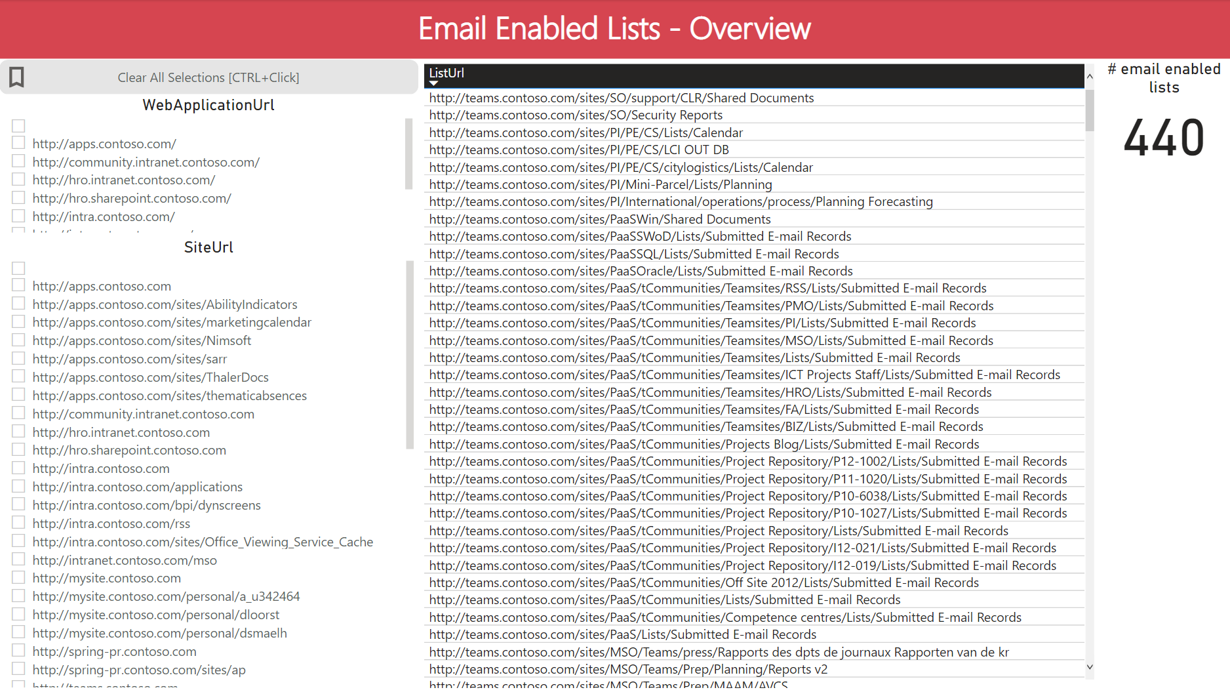

### Publishing Pages

This report provides an overview of all custom page layouts, instances used of the custom page layouts and customized pages in the farm.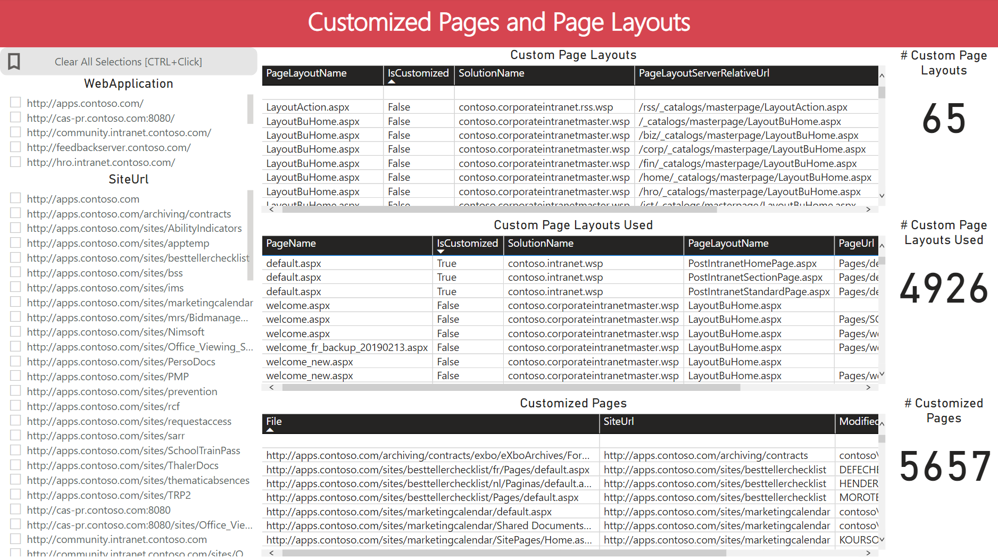

### Publishing Sites

This report provides an overview of all publishing sites and all publishing pages in the farm.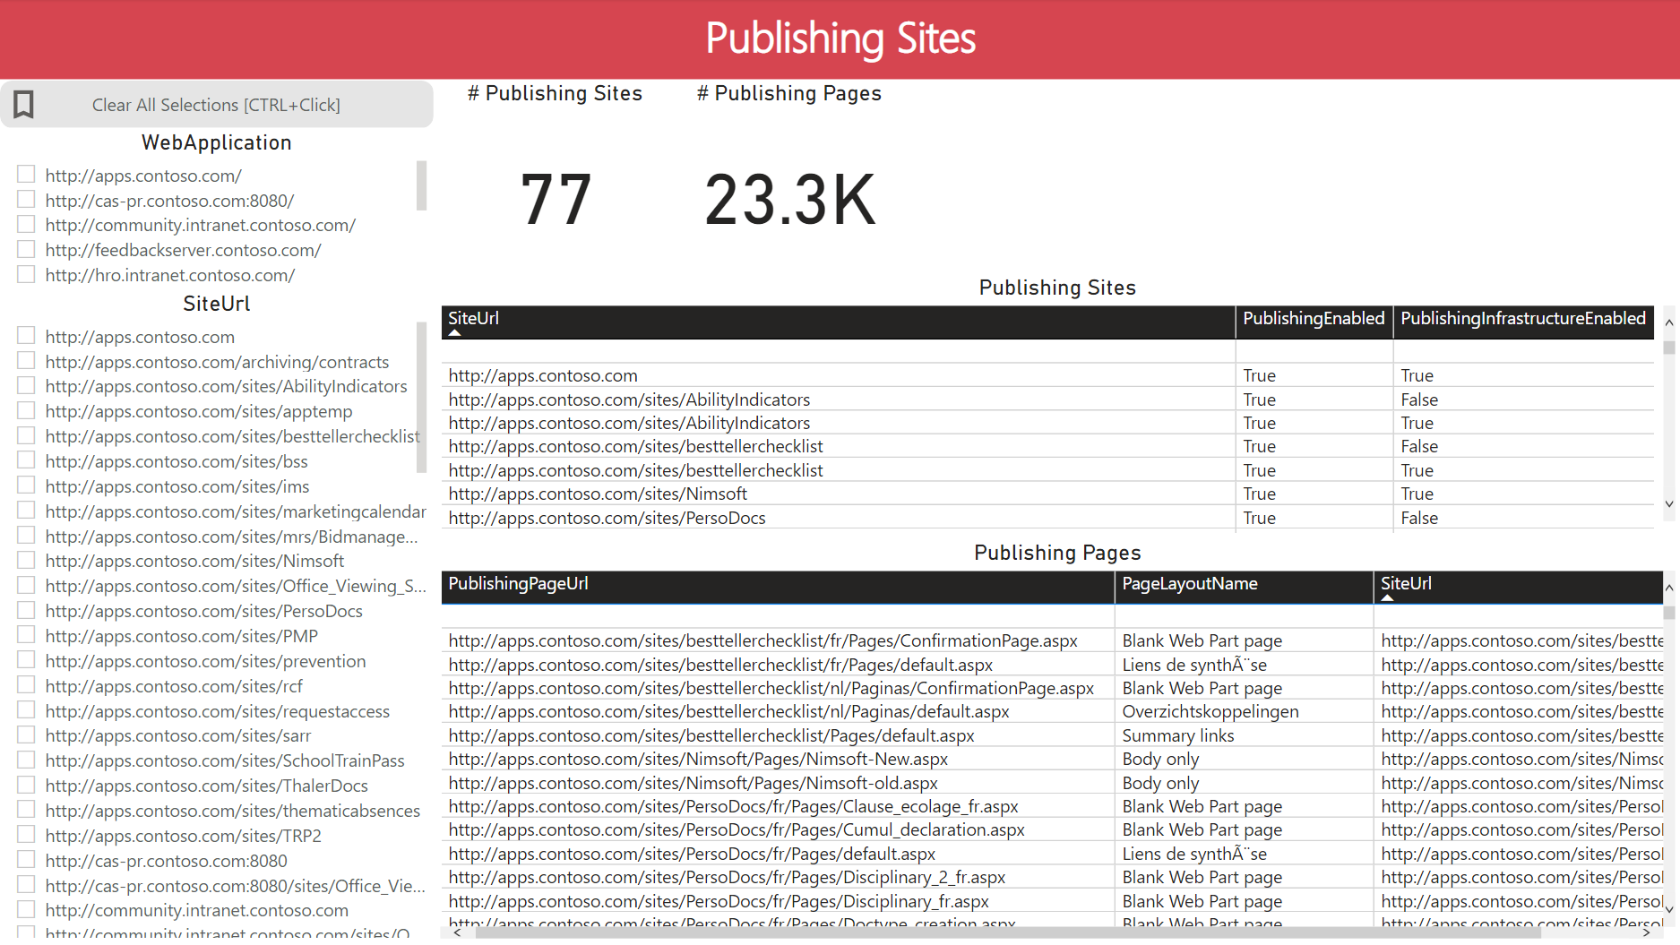

### Content Types and List Templates

This report provides an overview of all custom content types and list templates used in the farm.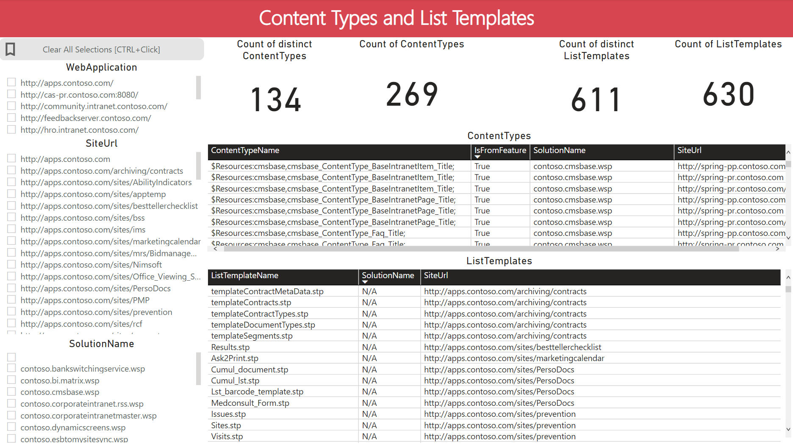

### Custom Fields

This report provides an overview of all custom fields used in the farm.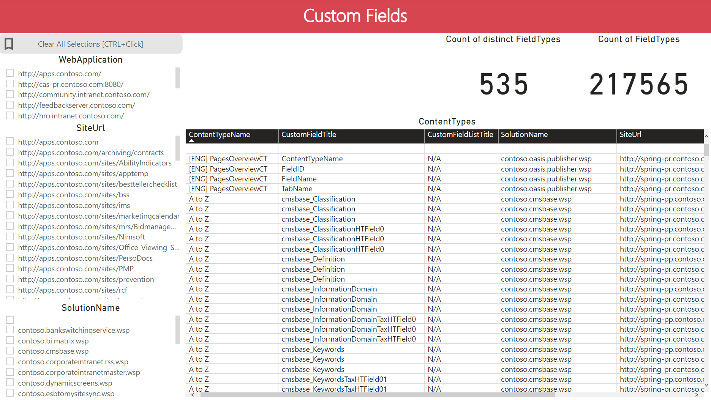

### Custom Permission Levels

This report provides an overview of all custom permission levels used in the farm.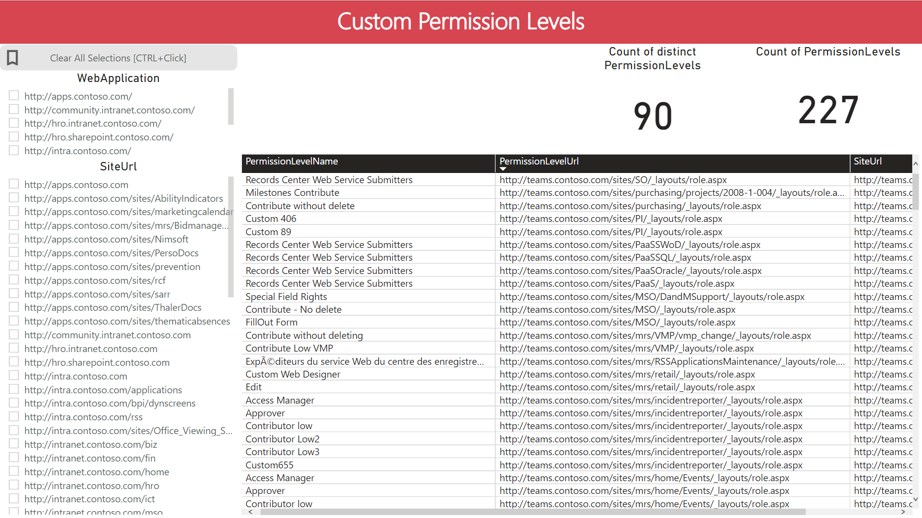

### Non-default Master Pages

This report provides an overview of all non-default “master pages” in the farm.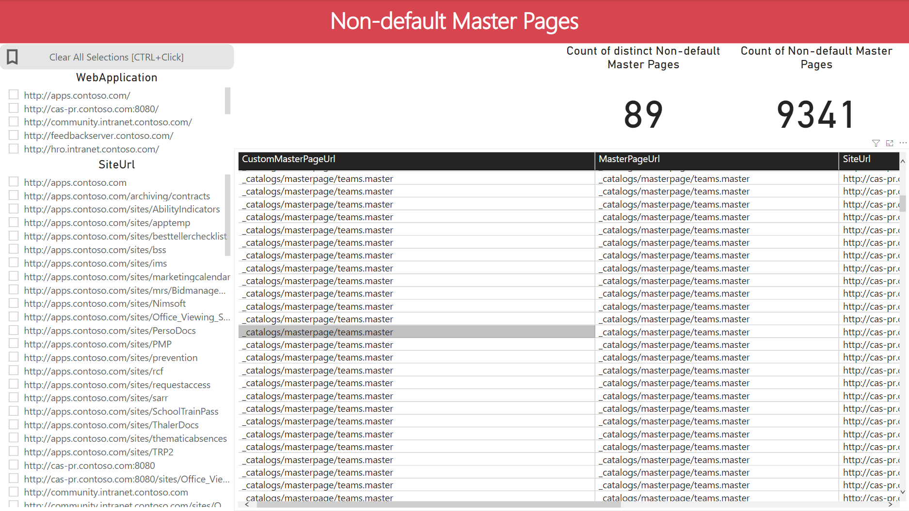

### Unsupported Web Templates

Drill down of the usage of non-supported web templates in the farm. Additional filters are available to filter on template name.

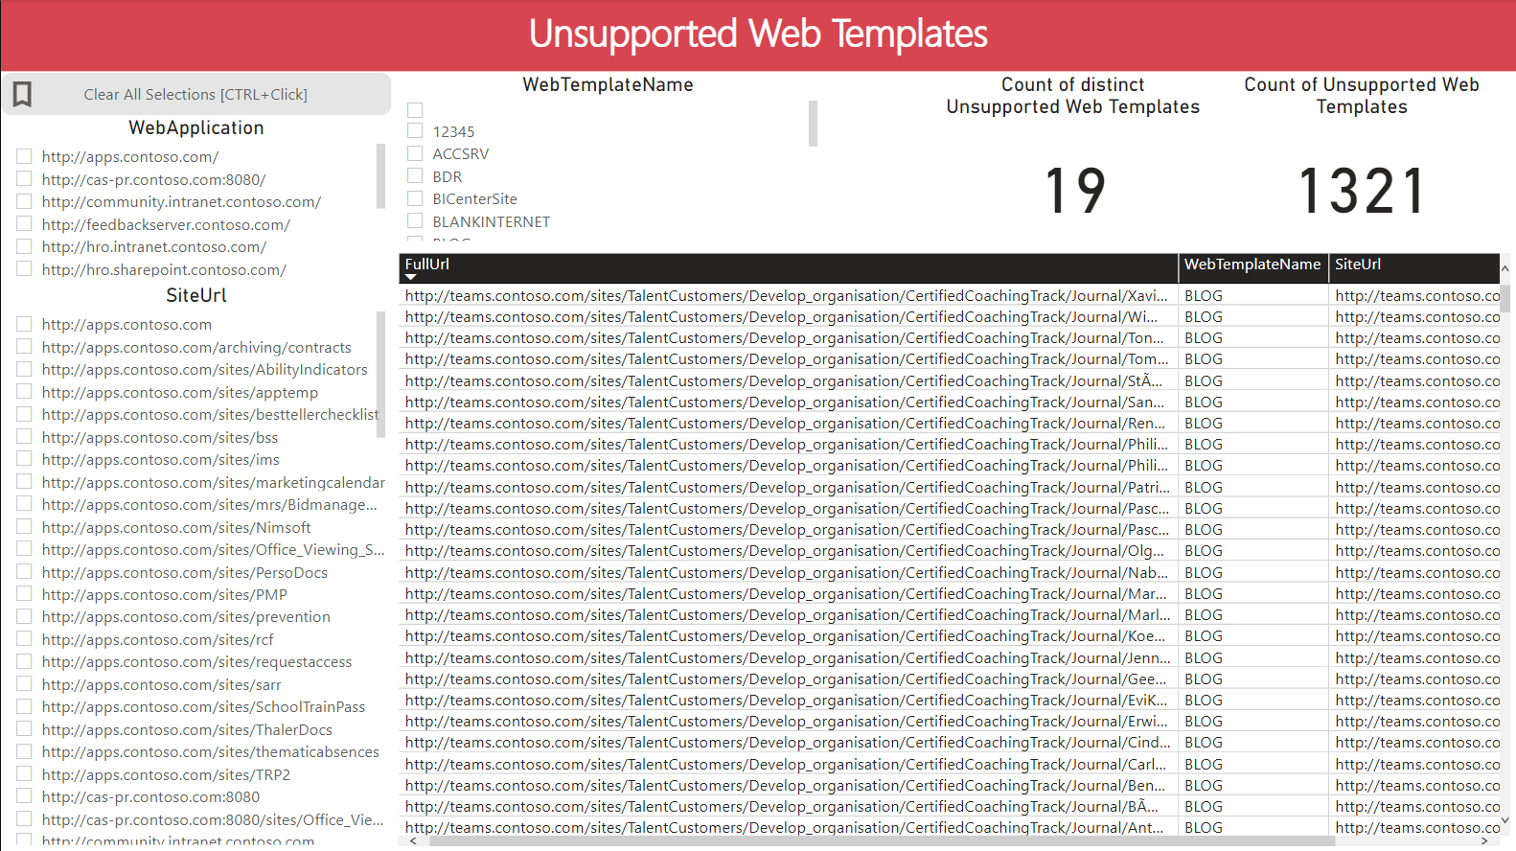

### Locked Sites

This report provides an overview of locked sites in the farm.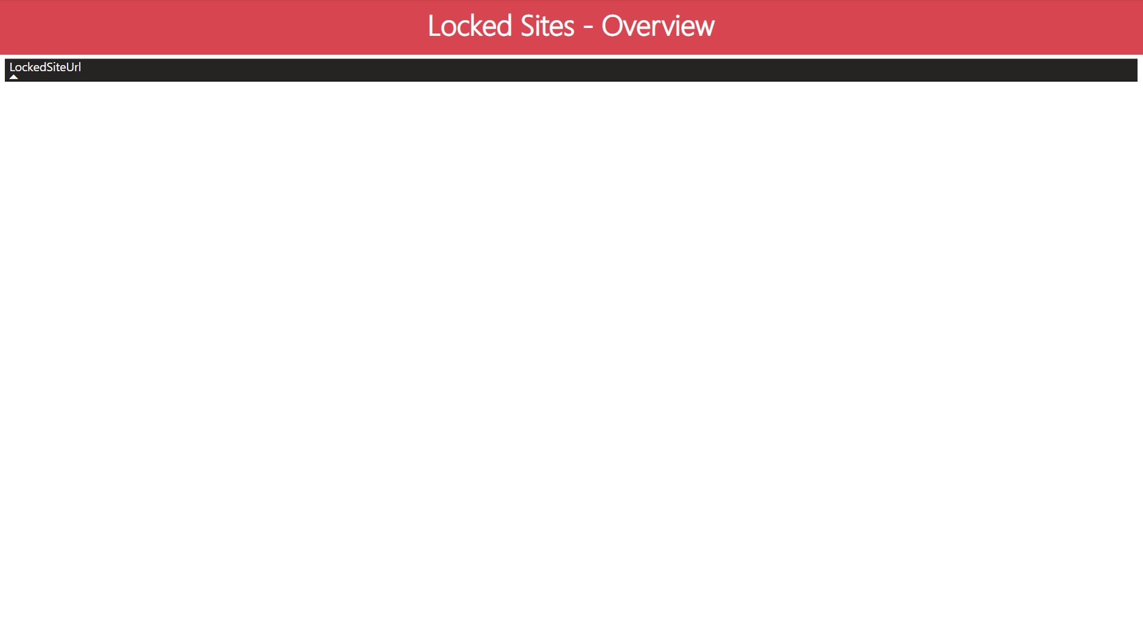

### Custom User Profile Properties

This report provides details about the usage of custom properties in the user profile data in the farm.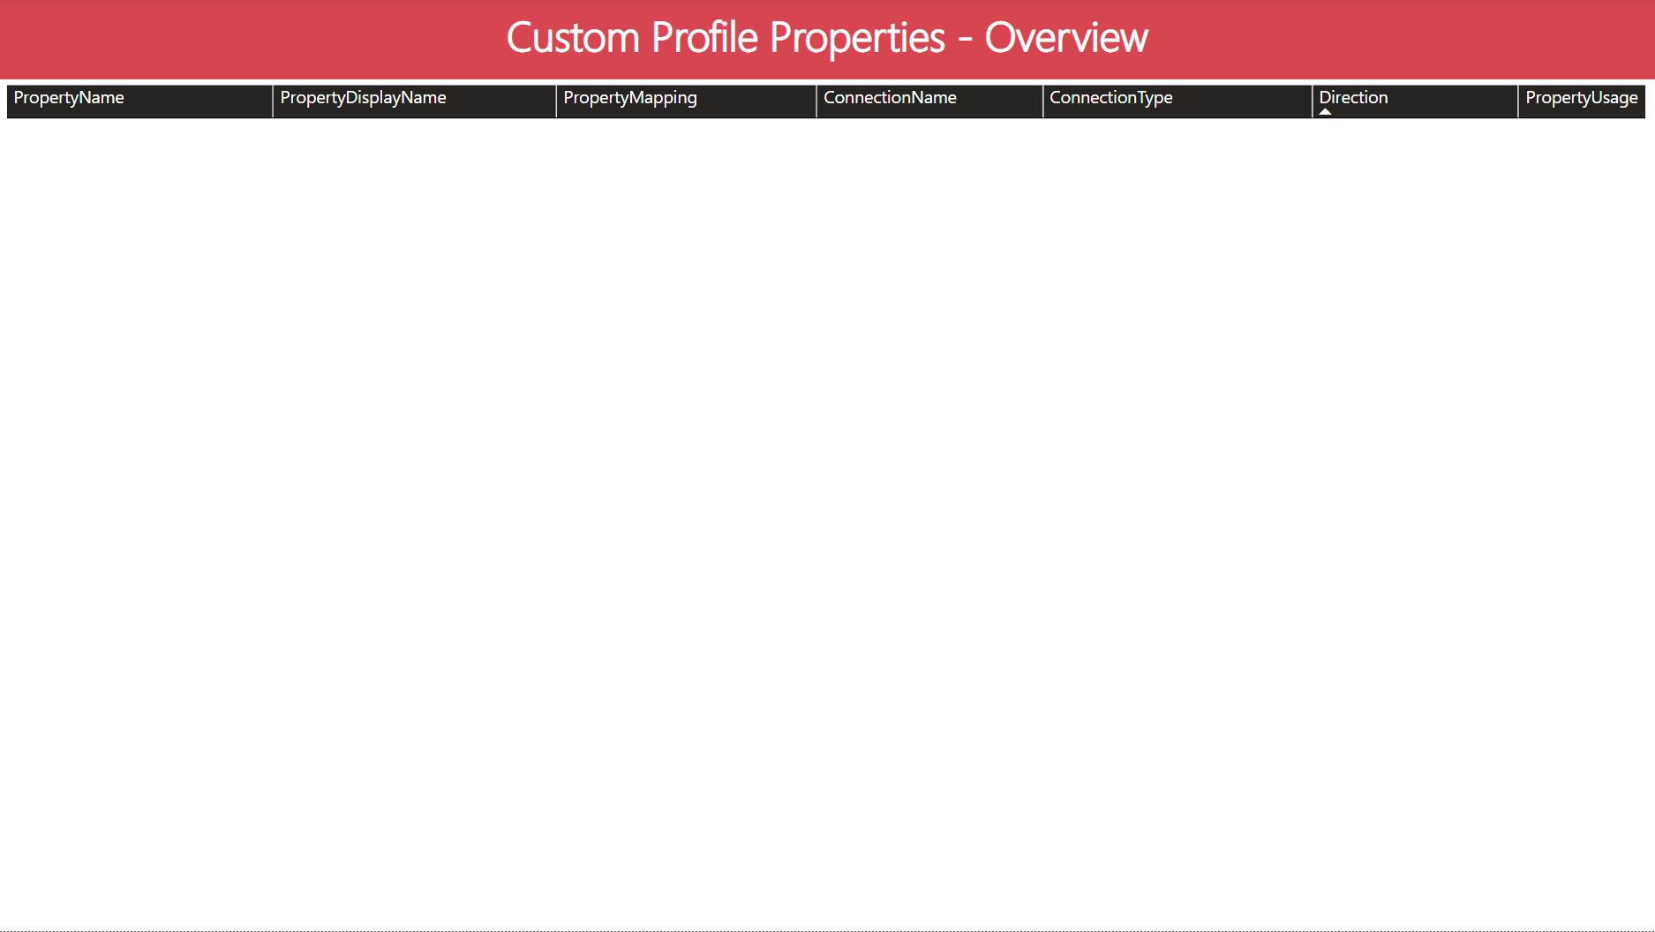

### Managed Metadata Libraries

This report provides details about the usage of managed metadata columns in lists in the farm.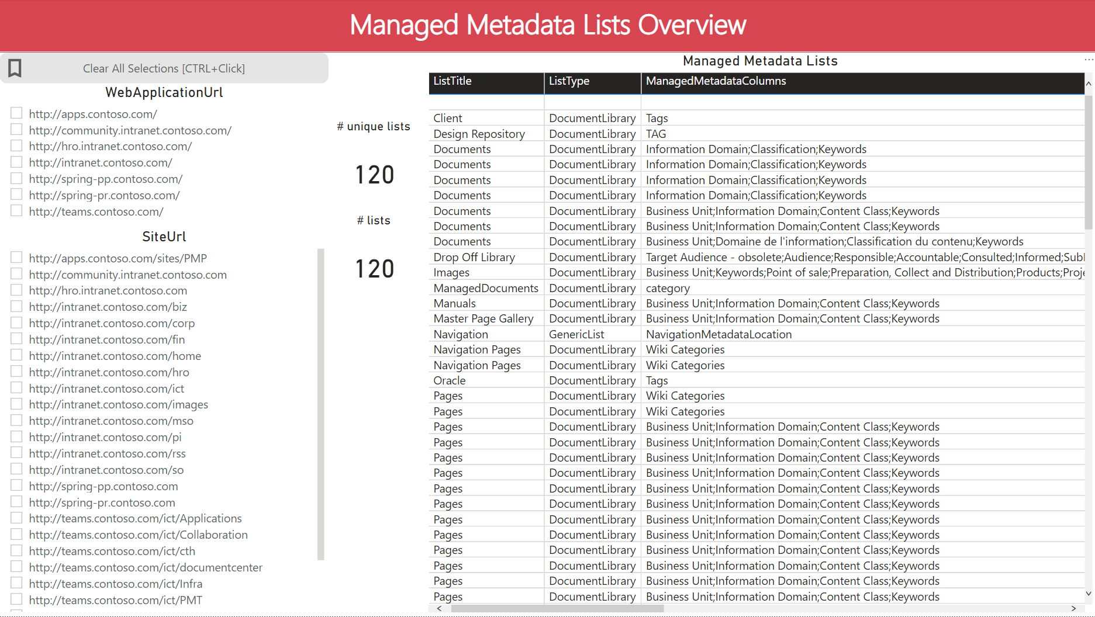

### IRM (INFORMATION RIGHTS MANAGEMENT) Enabled Lists

This report provides details about the usage of IRM enabled lists in the farm.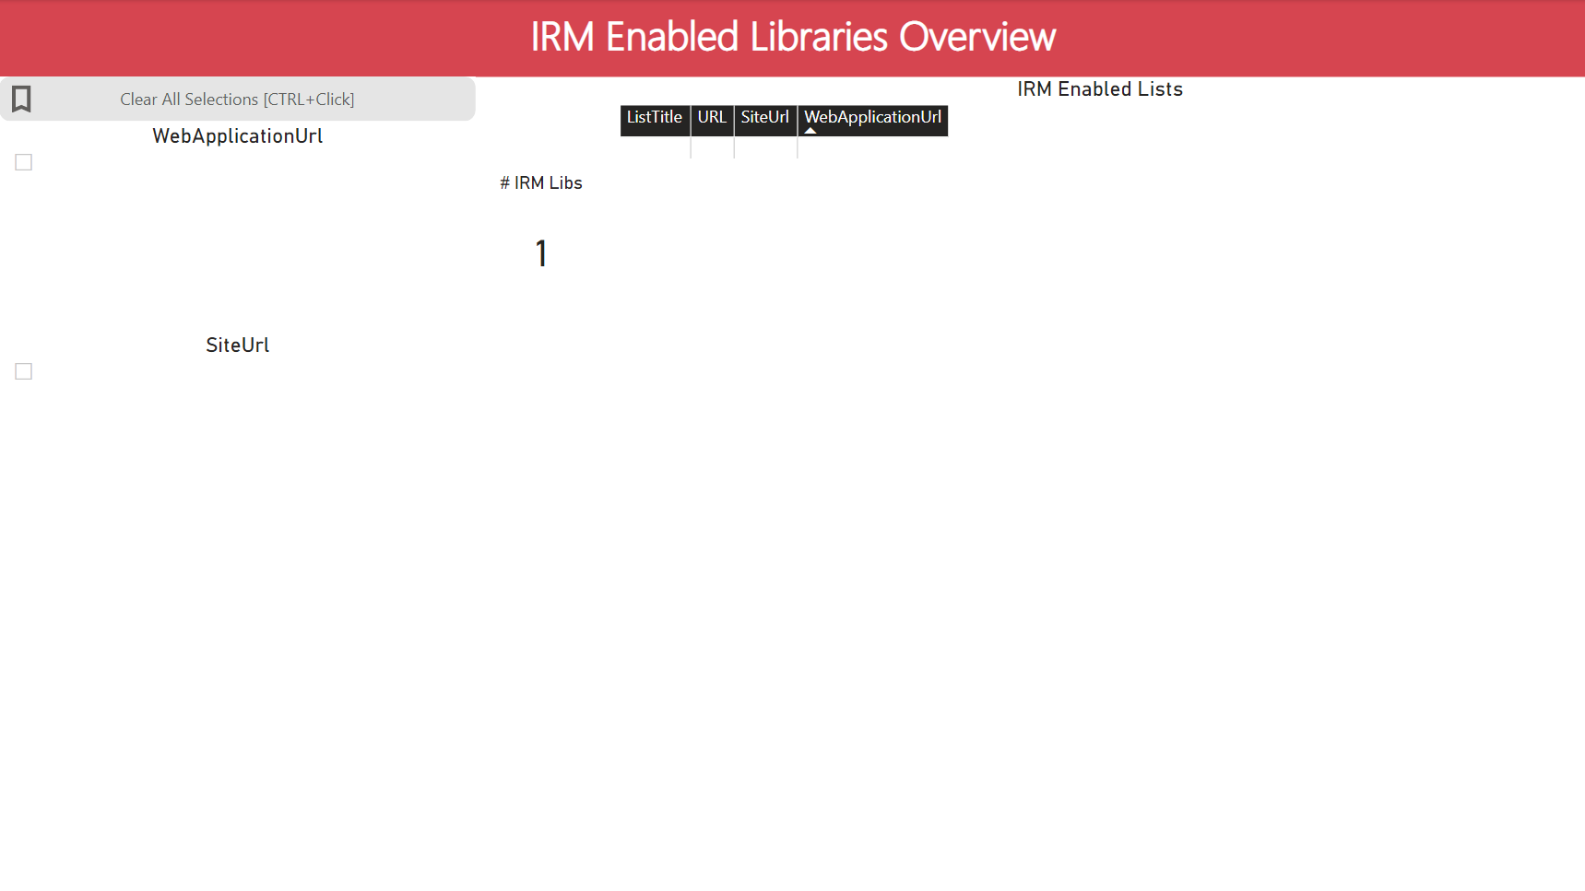

### Long OneDrive URL’s

<To be completed – Report not yet included – Waiting on input files>

## Overview of OPTIONAL “Report Pages” in the Power BI Report

### Web Owners Overview

Much like the Site Owner overview, but this one drills down to the (Sub) Web Level

NOTE: The data needed for this report page is not included in the default SMAT data collection. See topic 1.2.1 for more information.

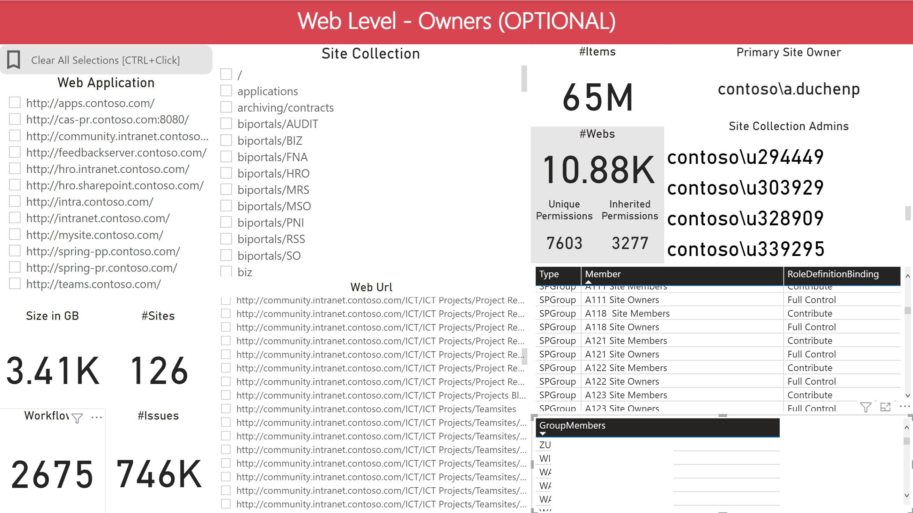

### Dashboard

This dashboard acts much like the “Farm Overview” but includes counters for data that require both OPTIONAL data collection scripts to be executed.

NOTE: The data needed for this report page is not included in the default SMAT data collection. See topic 1.2.0 & 1.2.1 for more information.

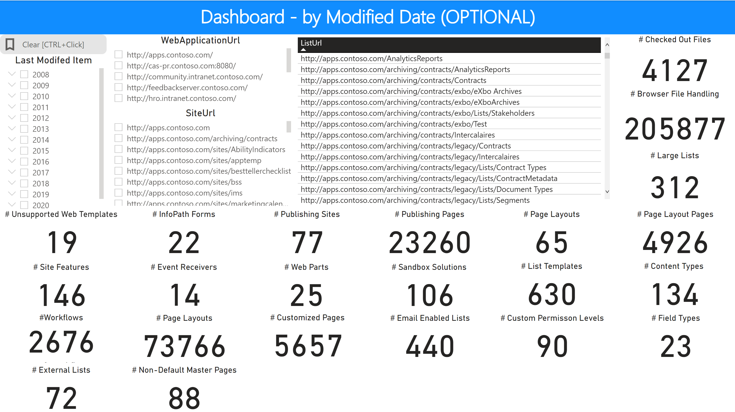

### Last Modified by Content

Drill down from Web Application all the way down to list level, showing the last modified date for any item(s) based on the selected scope. This is a view to try and determine what content has not been touched in a long time.

NOTE: The data needed for this report page is not included in the default SMAT data collection. See topic 1.2.0 for more information.

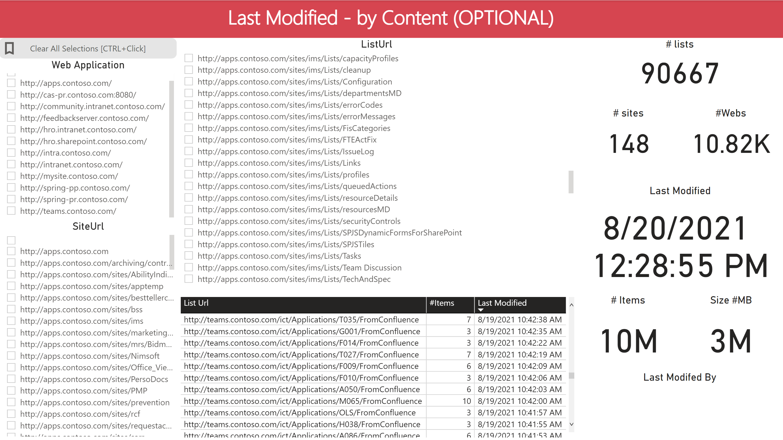

### Last Modified by Date

Based on the same data as 1.5.2, but this time we start the drill down from the Last Modified Date.

NOTE: The data needed for this report page is not included in the default SMAT data collection. See topic 1.2.0 for more information.

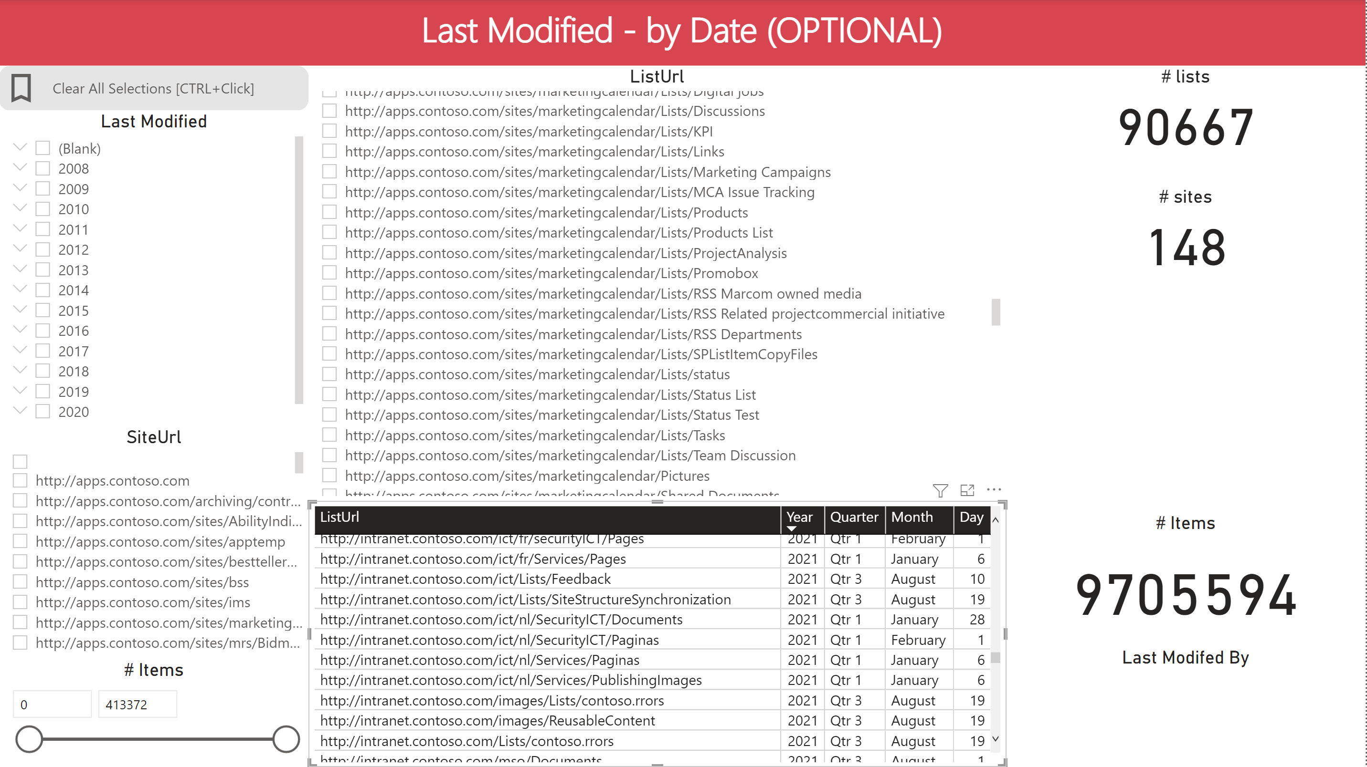

## Troubleshooting

Normally, when you don’t touch the SMAT output files, the CSV data should import without any issues popping up. Below we will add any “exceptions” that we encounter over time.

### Import Errors

#### WorkflowAssociations2013-detail.csv

We encountered an SMAT data collection where the “WorkflowAssociations2013-detail.csv” file had import errors due to several rows that were “inconsistent” with the table columns. It appeared to be the “WorkflowDescription” column text value that contained a carriage return, causing the CSV output to continue the rest of the rows data on a new row.

Using backspace you can re-join the description to be on a single line.

### Other Errors (place holder for any future exceptions)